ASK means **Amplitude Shift Keying** (also known as ON-OFF keying). It’s one of the Modulation Scheme used to transmit Digital Data using High Frequency carrier signal. It’s very simple and popular method. It transmits 1’s and 0’s of Digital Data by transmitting carrier or no carrier like

·         Bit 1 (logic high) is Transmitted with carrier frequency Fc

·         Bit 0 (logic low) is Transmitted with no carrier

Means series of bits – bit stream is transmitted as carrier ON and carrier OFF. That’s why it is also known as ON-OFF keying.

The figure given below shows Waveforms for ASK Modulation.

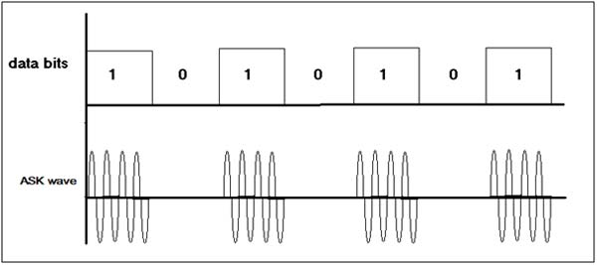

*Fig. 1: Image Showing Waveforms for ASK Modulation*

The first Waveform is bit pattern – data bits. 2nd Waveform shows ASK Modulation – for data bit 1 carrier signal (with frequency Fc) present but for data bit 0 there is no carrier signal. Usually carrier frequencies are higher than (100s of KHz) data rate. So in Single bit period several cycles of carrier are transmitted.

Here given Circuit demonstrates how ASK Modulated wave can be generated. The Circuit is build using [**IC555**](https://www.engineersgarage.com/555-timer-circuits). The bit stream can be given as input, and as an output IC555 generates ASK Wave. In this experiment instead of bit-stream, Square pulses are applied as input that can represent Logic High and Logic Low as bit 1 and bit 0. To generate Square pulses one more IC555 is used.

**Circuit Description**

There are two sections in the circuit

1.      ASK Modulator

2.      1 KHz Pulse Generator

Please refer Circuit Diagram Tab

**Pulse Generator**

IC555 is connected in Astable mode. It will generate continuous pulses at 1 KHz frequency. The frequency is determined by RC components R4, R5 and C3 as

F = 1.44 / (R4 + 2×R5) × C3

This 1 KHz pulse output is connected to reset pin (4) input of 2nd IC555 that works as ASK Modulator.

**ASK Modulator**

As shown in figure IC 555 is configured as Astable Multi vibrator. When its reset pin is high it generates continuous Square pulses with frequency

F = 1.44 / (R1 +2×R2) × C1

And when its reset pin is low its output is also low. The values of R1, R2 and C1 are selected as to get desire carrier frequency. The carrier frequency is selected as 100 KHz. Let us see how values of R1, R2 and C1 are calculated.

**Circuit Designing**

Assume C1 = 1 nF = 1 × 10-9F

Substituting this value in to above equation

F = 1.44 / (R1 + 2×R2) × 10-9

Because desired frequency is 100 KHz

100 × 103= 1.44 / (R1 + 2×R2) × 10-9

R1 + 2×R2 = 1.44 /( 105× 10-9)

R1 + 2×R2 = 14400

Now to get around 50% duty cycle R2 > R1, so let us take R1 = 3.3 K.

So

                                                            2×R2 = 14400-3300 = 11100

So                                                        R2 = 5550 = 5.5 K

The nearest practical value can be 5.6 K.

Thus finally R1 = 3.3 K, R2 = 5.6 K and C1 = 1 nF. Instead of selecting fixed value of R1, a Potentiometer is used to tune the frequency and get exact value of 100 KHz.

Similarly we can determine values of R3, R4 and C3 to generate 1 KHz frequency. To find out these values start with assuming C1 = 0.1 µF. So from equation

 F = 1.44 / (R4 + 2×R5) × C3

1000 = 1.44 / (R4 + 2×R5) × 10-7

(R4 + 2×R5) = 1.44 /( 103× 10-7)

(R4 + 2×R5) = 14400

Again we can select same R4 and R5 values as 3.3 K and 5.6 K respectively. And to get exact 1 KHz frequency we can use Potentiometer instead of fix value resistor for R4.

**Circuit Setup**

The Circuit can be built on Bread Board or on general purpose PCB.

·         On Bread Board, place all the components and make necessary connections as shown in Circuit Diagram

·         On general purpose PCB, mount and solder all the components and connect components as per Circuit Diagram

Next, apply 5 V to the Circuit through power supply and connect output of Pulse Generator and ASK Modulator to both the channels of DSO (or CRO) using CRO probes.

**Image of Circuit Setup**

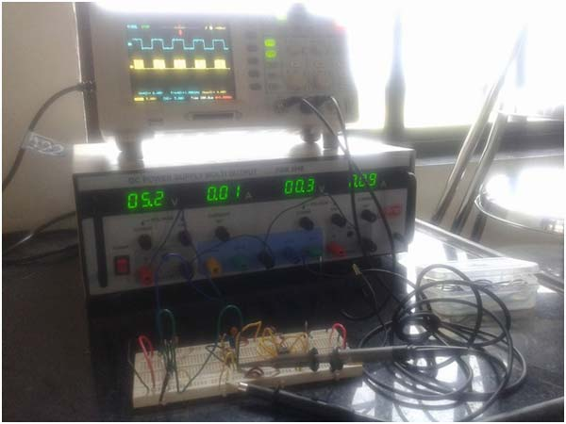

*Fig. 2: Image Of Circuit Setup for ASK Modulation*

**Circuit Operation**

1 KHz pulse input is given to reset pin 4 of IC555. When reset pin is given low logic the internal flip flop resets and IC555 gives low output. When reset pin is high IC555 works normal and generates Square Wave of Frequency determined by RC components in the output. So when bit 1 or logic high is given as input to reset pin a 100 KHz carrier is generated in the output and when bit 0 or logic low is given IC555 gives low output as requirement of ASK Modulated output.

**Here is the Output Image of given Circuit**

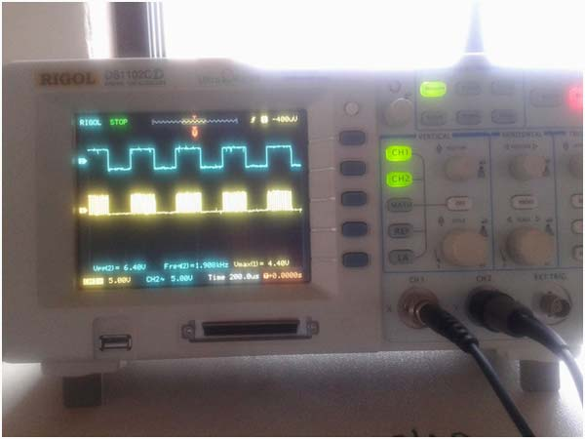

*Fig. 3: Image showing Output Result of ASK Modulation*

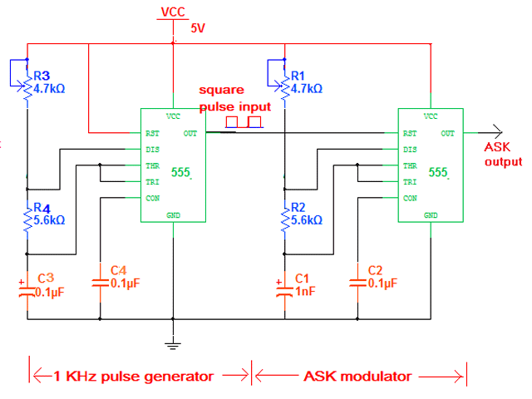

## omment transmettre des informations numériques par radio fréquence (RF) ?

La radio est un système de communication utilisant la propagation dans l'espace des ondes électromagnétiques.

Le signal à transmettre est de type numérique : il s'agit d'une sortie [UART](http://bts2m.free.fr/TP_Arduino/01_UART.html) 600 bauds.

Nous ne pouvons pas transmettre par radio directement ce signal :

* sa fréquence est trop basse (longueur d'onde trop élevée)
* signal carré, donc encombrement spectral très important.

Nous allons donc moduler une sinusoïde appelée porteuse. Quelle type de modulation utiliser ?

La modulation FSK est imposée par le module Kiwi : elle est fiable et plus simple qu'une PSK.

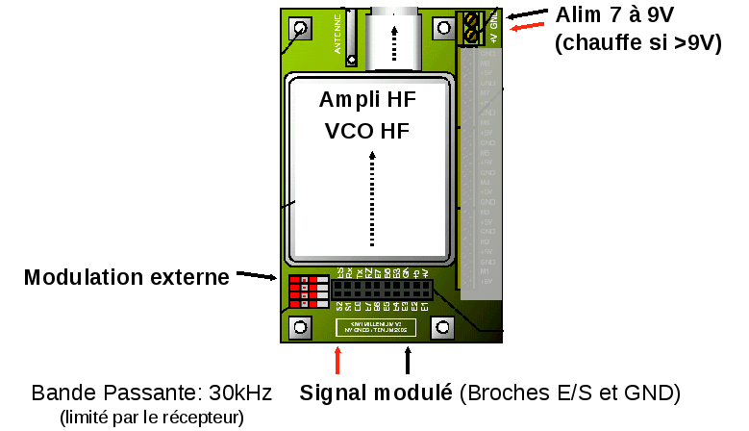

## Modulations numériques de base

Une porteuse sinusoïdale possède trois paramètres qui sont l’amplitude, la fréquence et la phase. Ces trois grandeurs sont toutes susceptibles de modulation par déplacement :

* la modulation par déplacement d’amplitude ASK (Amplitude-shift keying)
* la modulation par déplacement de fréquence FSK (frequency-shift keying)
* la modulation par déplacement de phase PSK. (Phase-shift keying)

 Dans un message numérique, deux états sont à coder, le 0 et le 1 logiques. Ces différentes modulations consistent donc en les opérations suivantes :

* ASK : Coder le 0 par une amplitude de signal égale à 0, et le 1 par une amplitude A.
* FSK : Coder le 0 par une fréquence fa, et le 1 par une fréquence fb.
* PSK : Coder le 0 par une phase de référence égale à 0, et le 1 par une phase de 180°.

### La modulation bi-fréquence ou FSK

Si la porteuse est modulée par un signal numérique, elle saute d’une fréquence fa («0») à une fréquence fb («1»).

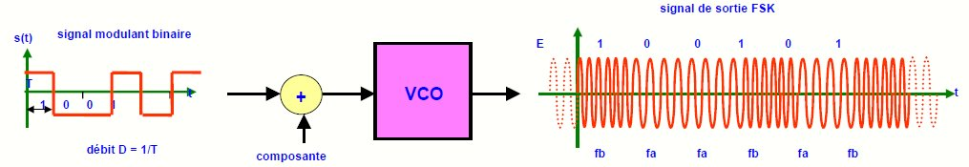

Notre modulation FSK a lieu aux fréquences Audio (900 Hz et 1500Hz),  comme les anciens modems.  
C'est le [mélangeur](http://public.iutenligne.net/electronique/launay/modulation_analogique/chap1/1-4-c.html) de l'émetteur Kiwi qui va translater ces fréquences dans les Radio Fréquences (porteuse à 137,05 MHz).

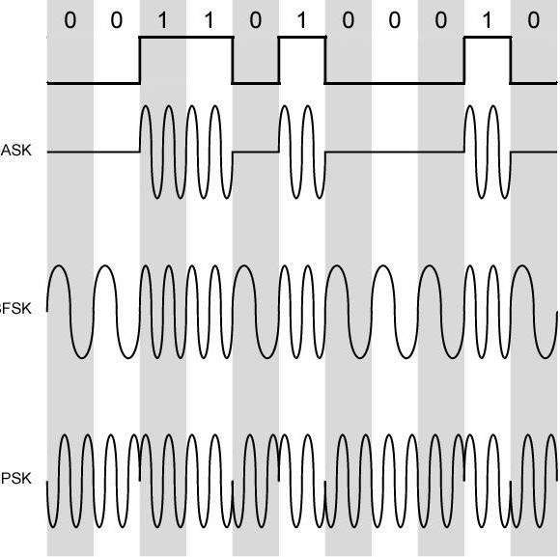

## Mise en œuvre d’un XR2206, test sur platine d’essai associé à un Arduino

Nous allons utiliser le circuit spécialisé XR2206, permettant de réaliser une modulation FSK avec un minimum de composants. Nous sommes partis du montage proposé dans son [datasheet](http://bts2m.free.fr/2016/documents/XR2206.pdf).

|  |
| --- |
|  |

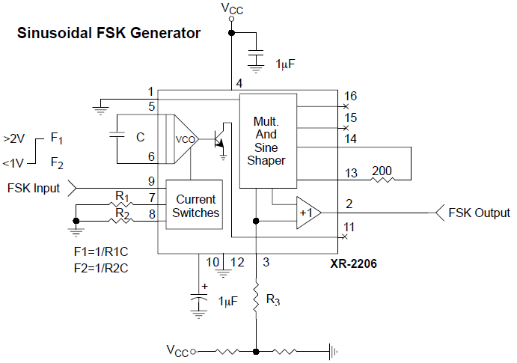

Nous avons dimensionné les composants afin de répondre au cahier des charges imposé par le module Kiwi, à savoir :

* Nous avons choisi un condensateur C = 10 nF;
* le 1 logique correspond à une fréquence de 1500 Hz. Après test, c'est R1 = 110 k       qui nous permet d'obtenir cette fréquence ;
* le 0 logique correspond  à une fréquence de 900 Hz. Après test, c'est R2 = 74,15 k     qui nous permet d'obtenir cette fréquence ;
* le FSK input nous est fourni par la sortie Serial 1 de notre Arduino Mega : Tx1

Voici les photos de nos essais, on remarque bien la basse fréquence (900 Hz pour un 0 logique) et la haute fréquence (1500 Hz) pour un 1 logique.

|  |
| --- |
|  |

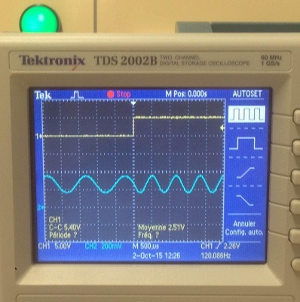

## Ecoute de notre modulation sur un PC

Nous avons ensuite envoyé le signal de sortie de notre montage sur la carte son d'un PC.

Pour supprimer la composante continue du signal, nous avons ajouté à la sortie un condensateur de découplage Cd = 100 nF.

Nous avons vérifié à l'oscilloscope que l'amplitude du signal était inférieure à 1 V.

|  |
| --- |
|  |

Nous avons alors constaté qu'au lieu d'avoir du silence entre 2 trames, nous avions en permanence du 1500 Hz.

En effet dans une liaison UART, le repos est un 1 logique.

Pour remédier à cela, nous avons trouvé [sur le site planète science](http://www.planete-sciences.org/espace/basedoc/Arduino_en_syst%C3%A9me_de_t%C3%A9l%C3%A9mesure_type_modulation_Kiwi) cette astuce.  
Il suffit d'ajouter un condensateur de 10 µF :

* le + sur la patte 3 du XR2206
* le - sur une patte "digital" d'un Arduino.  
  Lorsque l'Arduino met cette patte en haute impédance (pinMode(FSK, INPUT)), le XR2206 module normalement,  
  Lorsque l'Arduino relie cette patte à la masse, le XR2206 n'émet plus de signal.

## Encombrement spectral

## 

Pour augmenter la portée de notre émetteur Kiwi, nous devons limiter l'encombrement spectral de notre modulation.  
Cf le document planète sciences ci-contre.

Plus la tension de sortie du modulateur FSK est importante, plus le taux de modulation augmente.  
Et comme le montre la règle de [Carson](http://ebrois.free.fr/cours/electronique/fm/fm.htm), plus l'encombrement spectral sera important.

Comme l’émetteur fonctionne à puissance constante, l’énergie du spectre sera plus dense lorsque la bande passante de sortie sera réduite. Et ainsi la portée augmentée.

Pour mesurer notre encombrement spectral, nous avons utilisé une simple carte [TNT USB](http://www.ebay.fr/itm/USB-2-0-Digital-DVB-T-SDR-DAB-FM-HDTV-TV-Tuner-Receiver-Stick-RTL2832U-R820T2-A-/311491542276?hash=item488657bd04) du marché, d’une dizaine d’euros, équipée de la puce Realtek RTL2832U (c’est le point déterminant).  
Ainsi nous avons un scanner radio de 22Mhz à 2200Mhz, et le logiciel freeware [SDR Sharp](http://airspy.com/download/)  nous offre un analyseur de spectre RF... Pour plus de renseignement : [cliquez ici.](http://www.passion-radio.org/blog/sdr-sharp-dongle-rtl2832-r820t-e4000/76466)

Un  premier essai en modulation interne, nous a montré que l'encombrement spectral avait une largeur de bande B = 12,5 kHz. Soit une bande FM étroite (Narrow FM : NFM).



Voici une capture d'écran de notre premier essai en modulation externe avec R3 = 10 k.



On constate que notre modulation a une bande 3 fois plus large que la NFM...

## Réduction de notre spectre d'émission

D'après le schéma de l'émetteur Kiwi, lorsque le commutateur est en position K1 (modulation externe), notre modulation FSK arrive sur  un diviseur de tension. Puis rencontre un condensateur de découplage (C13) qui supprime la composante continue.

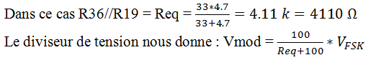

Il suffit donc d'ajouter une résistance à la sortie (2) de notre XR2206 pour diminuer l'amplitude du signal qui arrive sur le mélangeur de l'émetteur KIWI.

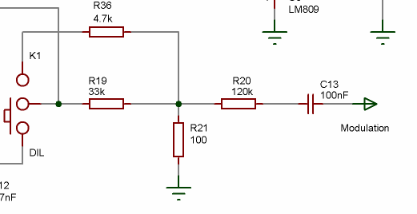

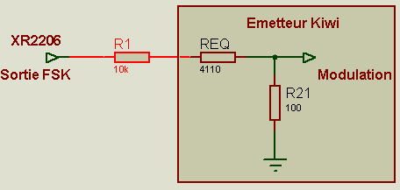

Lorsque l'on augmente R1, on diminue Vmod : 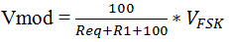

Après ajustement de R1, nous obtenons une modulation de fréquence bande étroite  (NFM) :



## Notre montage final :

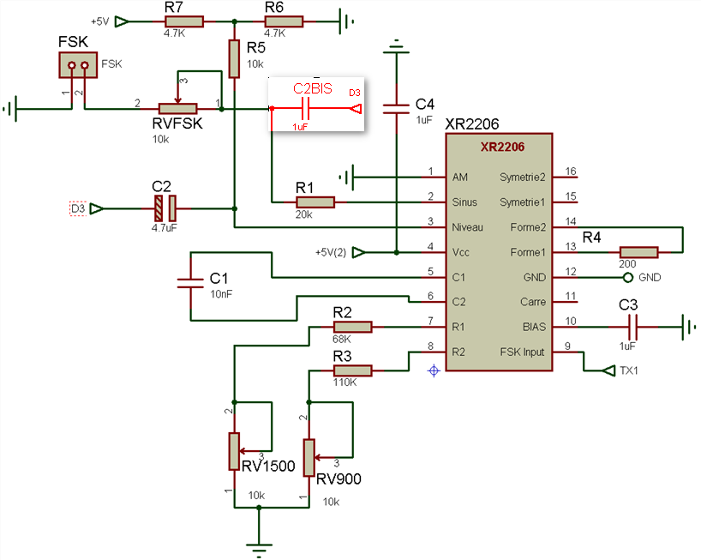

## Problème rencontré et solution à tester

Le jour des tests, nous avons constaté que notre modulation n'était pas compatible avec le démodulateur fourni par planète sciences.  
Heureusement,  le jour du lâcher nous avons pu utiliser notre démodulateur et récupérer les données.  
  
Piste pour le prochain projet :  
Il reste un résidu  de 1500 Hz lors du "silence" qui n'est pas parfait. Ce résidu ne s'entendait pas avec notre scanner radio mais il est visible à l'oscilloscope (amplitude 16 mV).  
Or d'après la documentation Planète Sciences ce silence est impératif pour le démodulateur "officiel".

Solution à tester :  
Placer un condensateur C2bis de 1 µF (en rouge sur le schéma) : borne 1 entre les résistances R1 et RVFSK, borne 2 sur le D3 de l'Arduino.

Fonctionnement :

* D3 est en haute impédance, C2bis ne modifie pas le circuit et le signal FSK est transmis
* D3 est reliée à la masse, C2BIS court-circuite (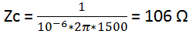 devant 4210 Ohms) le résidu à 1500 Hz : le signal FSK transmis est quasi-nul...

Radio Control /Remote Control and ASK (Amplitude Shift Keying) /OOK (On /Off Keying) have been around for some time, but there is limited coherent information on the subject and the associated hardware. Applications abound, including garage door openers, keyless entry, R-C toys, etc. These all utilize one-way communications. The most commonly used frequencies are 315, 330 and 434mHZ (most popular).

Numerous transmitters may actually share the same frequency and proximity, but they coexist only because of the brevity and low repetition rate of transmissions. Minimal information is transmitted –this consists of (8) bits of identification plus (4) additional bits of identification or variable control data.

The low data rate (4800 bits per second) is acceptable for identification and limited control with a typical (4) byte transmission requiring only 8mS. The protocol in this ASK ‘party line’ environment is very simple: first come, first serve, loudest or closest gets heard. Receiver address security is high, but transmission reliability is somewhat compromised by RFI (Radio Frequency Interference) and potential collisions where more than one transmitter may be transmitting simultaneously. Due to these limitations, the operator must occasionally push the button a 2nd time to open a door etc.

This discussion builds upon the previous (excellent) work of T.K. Hareendran: [**RF Based Wireless Remote Control System**](https://www.electroschematics.com/rf-based-wireless-remote-control-system/). It is limited to the transmitter and super regenerative receiver, but not the super heterodyne receiver as that piece has yet to be delivered –the results of testing this piece will be included as a subsequent comment. Future work will include an evaluation of the Holtek encoder /decoder devices that are required to complete the system.

**Photo of transmitters and receivers**

**[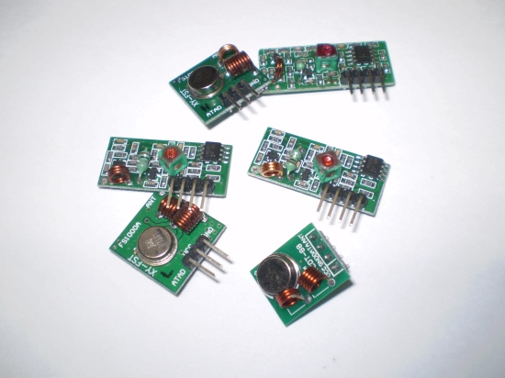](https://www.electroschematics.com/wp-content/uploads/2014/03/Bits-and-Pieces.jpg)**

**What is ASK /OOK?**

Amplitude shift keying is simply toggling between two RF power levels that denote serial “ones” and “zeros.” In the case of OOK, the zero is actually No carrier –for all practical purposes in this discussion, ASK and OOK are identical. OOK is functionally identical to CW (Continuous Wave) that has long been used for Morse code transmissions, but at a much higher character or data rate. ASK /OOK is much cheaper and easier to implement than the FSK (Frequency Shift Keying) modulation technique that is commonly used for data streaming applications.

**RC Transmitters**

The transmitter consists of a SAW resonator configured as an oscillator.  
The circuits all appear to be similar, but the layout varies depending upon the manufacturer –copies abound. The recommended supply voltage is 3 to 12V with power and range a function of the voltage. One neat thing about the transmitter is that they draw No (zilch) current when not operating because the keying transistor must be On to complete the circuit. Actual CW current runs between 9mA @ 3V to 40mA @ 12V, but that is a non-issue because it runs only when the push-button is pressed so the battery will likely never need replacing. Maximum legal RF power output is 10mW –with input power being up to 480mW, the efficiency must be low (or perhaps nobody really bothers to regulate such).

**Typical transmitter schematic**  
**[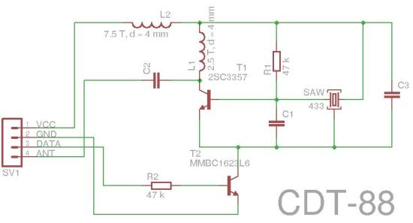](https://www.electroschematics.com/wp-content/uploads/2014/03/CDT-88-Transmitter-Schematic.jpg)**

**Typical transmitter photo**

**Why such sketchy specifications?**

I really had to dig in order to compile a coherent list of specifications. I believe that with such cheap hardware, limited profit margins, limited engineering staff and occasional functional failure, no manufacturer wants to accept liability –this is why they make few performance claims.

**Typical transmitter specifications** (compiled from numerous sources)

* Dimensions: 19 x 19 x 7.6mm (excluding pins) (some are even smaller)
* Interface: 3 or 4 pin header (0.1” pitch)
* Frequency: 315, 330 or 433mHZ (actually 33.92mHZ –also called 434mHZ)
* Frequency accuracy: ±150kHZ
* Supply voltage: 3 to 12V @ 9 to 40mA (when keyed) 0mA (not keyed)
* Maximum input power: 480mW @ 12V
* Modulation technique: ASK
* Maximum data rate: 8000 bits /sec
* Antenna length: 10 to 20cM
* Range: Up to 150M (subject to environment)
* Pinout: Pinouts vary, but are indicated on the circuit board

**RC Receivers**

Receivers fall into two categories: super regenerative and super heterodyne. While super heterodyne offers reduced noise, higher sensitivity and better selectivity (adjacent channel separation), it perhaps doubles the cost and is available from fewer vendors. Super regenerative receiver circuits appear to be very similar in design and have varying layouts depending upon manufacturer. Do not depend upon vendor’s circuit board photographs for proper circuit identification as some appear to be simply representative.

Two dimensional form factors are available for the super regenerative version: short and long. It appears that the long version was dimensioned after the larger super heterodyne version so that both have physically identical dimensions and pinouts so that they are interchangeable.

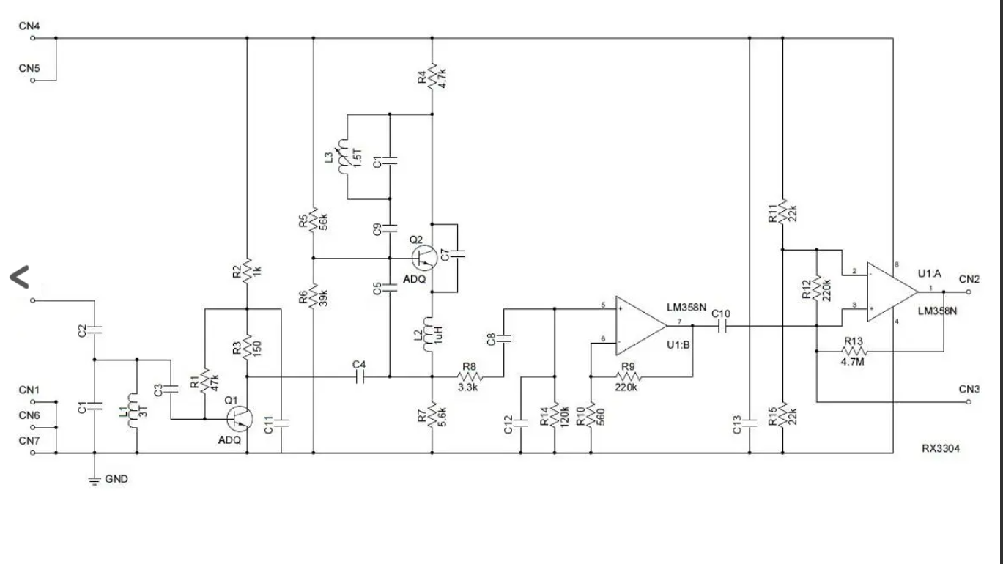

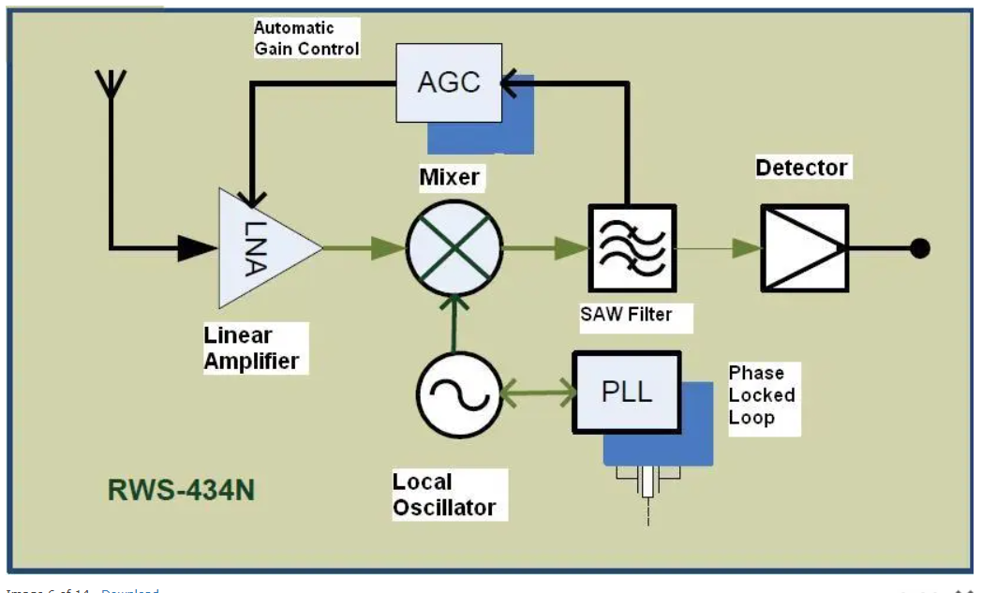

**Typical super regenerative receiver specifications** (compiled from numerous sources)

* Dimensions:
  + 30.5 x 14 x 9mm (short version, excluding pins)
  + 43.4 x 11.5 x 9mm (long version)
* Interface:
  + 4pin header (short version, 0.1” pitch)
  + (2) 4pin headers (long version)
* Frequency: 315, 330 or 434mHZ
* Supply voltage: 3.3 to 6V @ 6mA
* Sensitivity: -104dbm
* Bandwidth: 2mHZ (super regenerative)
* Modulation technique: ASK
* Output signal level: (Vcc -1V) /0
* Maximum data rate: 4800 bits /sec
* Antenna length: 10 to 20cM
* Range:
  + Up to 150M (subject to environment)
  + Up to 10M without antenna
* Pinout: Pinouts vary, but are indicated on the circuit board

**Super regenerative receiver function**

How it works is that the gain of the resonant stage continues to increase until the point of oscillation –at this point the oscillator self-quenches so that the oscillations die out for a period of time after which the cycle repeats. At the point of self-quenching, the detector output changes states as if there was an actual signal received. This results in a noisy output when no signal is being received and the serial signal synchronization device (decoder) is always working hard to synchronize on a legitimate signal and is subject to missing the first byte.

Other types of modulation schemes such as FSK provide a much cleaner output, but require a clear channel –however that is another discussion.

**Super heterodyne receiver specifications** (Wenshing RS-434N)

* Dimensions: 43.2 x 12.2 x 9mm
* Interface: (2) 4pin headers
* Frequency: 315 or 434mHZ
* Supply voltage: 3.5 to 5.5V @ 6.5mA
* Sensitivity: -115dbm
* Maximum data rate: 12kBaud
* Temperature range: -20 to 85°C
* Modulation technique: ASK

**Antennas**

Antenna lengths for both transmitter and receiver are generally specified between 10 to 20cm. For close-range interference-free operation, the receiver antenna may be omitted. To avoid interference in busy, high density environments (multiple RF links under your control), the transmitter antenna lengths may be reduced somewhat but not eliminated. I determined that the transmitter would sometimes not oscillate with no antenna connected –it needs an RF load. At least one vendor claims that the antenna needs to be connected to prevent damage due to load mismatch. Under such conditions, the resonant circuit can ring up higher than normal voltages.

**Maximum range experiment**

For a simple experiment to determine range, I connected a transmitter to a function generator set for a 2HZ square wave. An LED was connected to the data output of the receiver –note that the LM358 IC that is used as a detector /driver can both source or sink current, so I sourced an LED through a 1K limiting resistor –this seemed to provide good results. The receiver, being battery powered could then be hand carried to the reception limits at which the LED blinks incoherently. Without an antenna on the receiver, the range was 10M. With an antenna, the range was 100M. This is exactly what was expected.

**RC range experiment schematic**

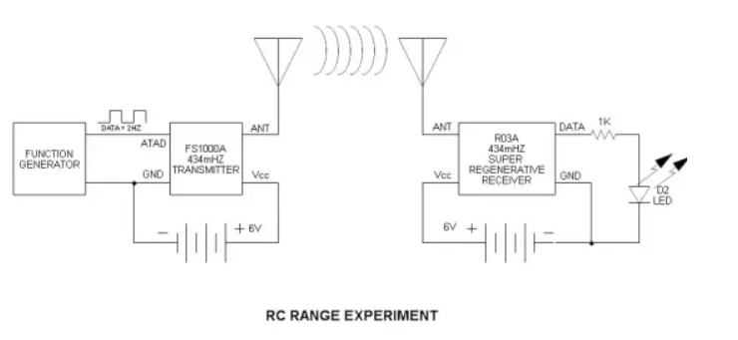

**No signal noise (super regenerative receiver)**

This is the nature of the beast –if no signal is received, there is an incoherent output signal otherwise called noise. The super heterodyne receiver (as far as I know) does not act like this, but can receive real noise (RFI) due to its high sensitivity rather than introducing its own noise like the super regenerative does. In the oscillograph observe the output noise. Also, observe the minimum modulation frequency –it clearly indicates that the super regenerative receiver cannot handle DC modulation due to the introduction of noise. This is a bit of trivia, but I think that the super heterodyne version will demodulate a DC modulating signal.

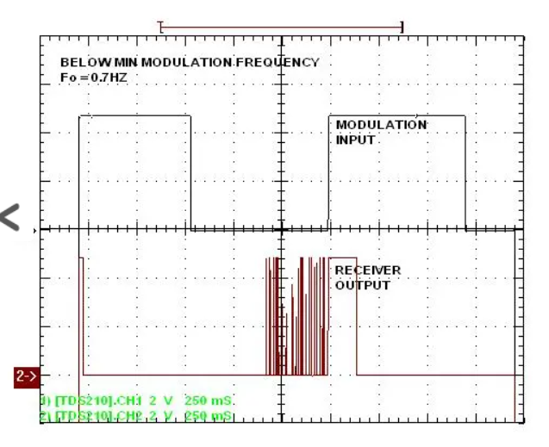

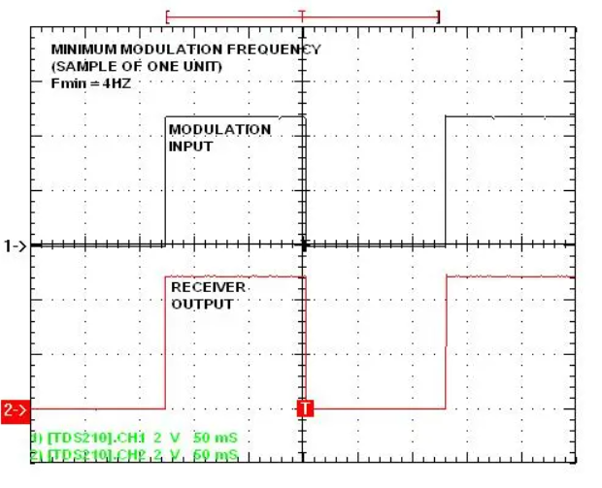

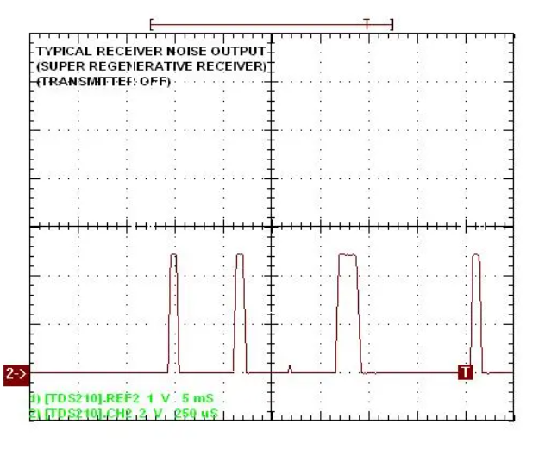

**Determining the max data rate**

The typical maximum data rate (4500 bits /S) appears to be marginal at best. I would reduce the data rate further if there were framing error problems –that is where the serial 1’s and 0’s do not occur within the acceptable time frame window. I believe that the super heterodyne receiver offers better performance in this regard.

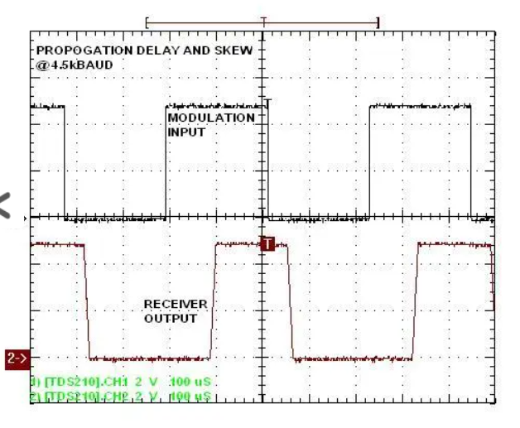

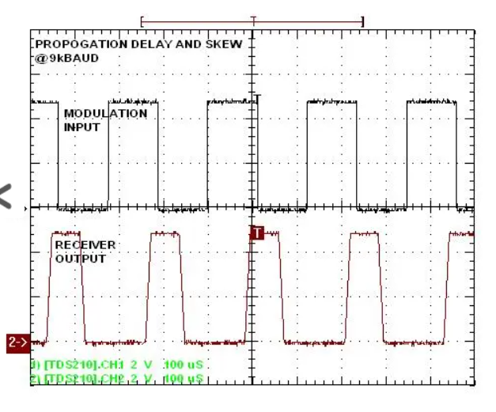

**Obtaining a transmitter /receiver pair**

Cost is about $5 for the pair containing the super regenerative receiver –very inexpensive, and you may find the shipping exceeds this figure. I had good results obtaining devices on eBay from a domestic supplier –they are made in China and, of course, you may purchase direct, but shipping time may be an issue. The first transmitter that I purchased from the [**Robot Shop**](http://www.robotshop.com/en/seeedstudio-433mhz-low-cost-transmitter-receiver-pair.html) malfunctioned and despite wonderful web page claims, they provided no support, so make sure that you purchase a backup set. I think that the SAW resonators may be fragile like crystals.

**SAW confusion**

Do not confuse SAW (Surface Acoustic Wave) devices with SAW (Synthetic Aperture Window) Radar. SAW radar can actually render a 3D image of the inside of your residence from a [**Black Helicopter**](http://www.goodreads.com/book/show/687257.Black_Helicopters_over_America) (by my namesake, the late Jim Keith –no relation –LOL).

**For more reading**

[**http://jap.hu/electronic/rf/el9805.pdf**](http://jap.hu/electronic/rf/el9805.pdf)  
[**http://valontechnology.com/images/REGEN.PDF**](http://valontechnology.com/images/REGEN.PDF)

**For the future**

Encoder and decoder application info

**Undocumented words and idioms** (for our ESL friends)

party line –idiom referring to early telephone landline systems where numerous phones were connected to one ‘party line’ due to want of circuits –each subscriber had a different ring pattern –sometimes it was necessary to tell nosy neighbors to hang up because the additional telephones loaded down the signal excessively –LOL –this was in my parents’ day…

zilch –slang indicating the quantity ZERO

# Common Modulation Transmitters | Circuits and Simulation Matlab Codes| AM, FM, ASK, PSK, OOK

# Common Modulation Transmitters | Circuits and Simulation Matlab Codes| AM, FM, ASK, PSK, OOK

January 4, 2023 by [Charles Clark](https://www.circuitsgallery.com/author/editor-circuitsgallery/) [Leave a Comment](https://www.circuitsgallery.com/common-modulation-transmitters/#respond)

If you are looking for easy and smart electronic projects, we suggest you go for the transmitter projects. You can find many projects with transmitters circuits but in this article, we’ve discussed 8 unique and easy-to-make projects of common modulation transmitters circuits such as AM, FM, ASK, PSK, OOK, etc. and we’ve also used Matlab codes that make them smarter.

Below you can find the following transmitter circuits with simulation –

1. **A simple 555 timer AM transmitter circuit**that is suitable for [school projects or science fair](https://www.circuitsgallery.com/automatic-iron-box-best-electronic-science-fair-project-for-school-students/) projects.
2. **The simplest and single-transistor FM wireless transmitter circuit** which also can be used for [school projects or science fair](https://www.circuitsgallery.com/top-10-science-fair-electronics-projects-for-school-students/) projects.
3. **Binary Amplitude Shift Keying (BASK) or On-Off Keying (OOK) circuit with diagram**– which are one of the best digital modulation techniques.
4. **A highly-integrated FM audio signal transmitter circuit**using a Hi-fi audio chip named VMR6512.
5. One of the basic types of digital modulation techniques**– Amplitude Shift Keying (ASK) using the Matlab function.**
6. **The Frequency Modulation (FM) in MATLAB.**
7. A detailed discussion on **binary phase-shift keying (BPSK)**and applications of**PSK**modulation with **Matlab codes.**
8. The plotting of**AM signals using MATLAB.**

All the basics of transmitters with Matlab are discussed below and all these above projects are demonstrated with proper simulations. Let’s check them one by one below.

## 1. Simple 555 Timer AM Transmitter Circuit Schematic for Science Fair Project

Do you know what Amplitude Modulation (AM) in the transmitter is? AM is a modulation technique where the amplitude of the carrier varies according to the input message signal. AM has been a widely used modulation technique such as walkie-talkie applications due to its longer range but has the disadvantage of lesser noise immunity.

In this project, the 555 multivibrator generates a frequency of AM range, so you can receive the transmitted audio signal in the AM radio receiver. Let’s explore this simple school project below.

### Circuit Diagram of Amplitude Modulation Transmitter

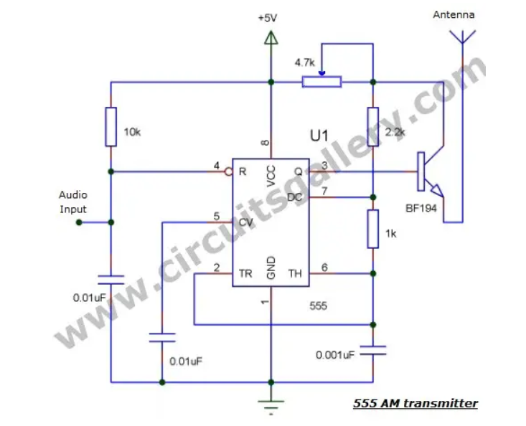

### Components Required for 555 Timer AM Transmitter Circuit

1. 555 IC
2. Transistor BF 194
3. Resistor (10K, 1K, 2.2K)
4. Pot 4.7K
5. Capacitor (.001uF,.01 X2)
6. Antenna

### Simple 555 Timer AM Transmitter Circuit Working Principle

* For a better understanding of the working, please read our article on the 555 astable [multivibrator](https://www.circuitsgallery.com/multivibrator-circuits-and-calculators-for-digital-control/) which I had explained in detail.
* Here the carrier signal for AM modulation is generated by a 555 timer operating in astable multivibrator mode with the oscillation frequency set to AM range.
* Input i.e. the message signal is applied to the reset terminal (4th pin of multivibrator).
* If the amplitude of the input message signal is increased, 555 starts to turn ON as it’s connected to the 4th pin. (Since 4th terminal connected to VCC causes it to turn ON because it is an active low logic pin).
* And if the amplitude is decreased, it starts to turn OFF. (As the 4th terminal [connect to ground](https://www.circuitsgallery.com/what-happens-if-you-connect-neutral-to-ground/) or 0V causes the 555 to turn OFF.)
* The output (3rd pin) is connected to the base of a BF194 transistor as it can operate at high frequencies.
* The emitter terminal of the transistor is connected to an antenna for better transmission. You can use a simple conducting wire as the antenna.
* BF 194 can drive high frequency, here astable multivibrator generates a radio frequency of AM range, then you can receive the transmitted signal in the radio receiver.

### Simple 555 Timer AM Transmitter Circuit Simulation Using Proteus

Here is the screenshot of the simulation in Proteus.

### Components Pin Out

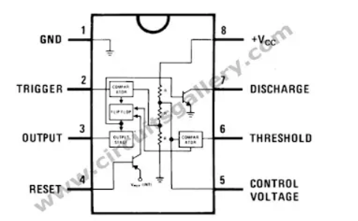

A simple 555-timer AM transmitter circuit is important in terms of communication engineering using simple electronics. This is often an alternative to FM transmitters, but it has its own limitations.

## 2. Most Simple FM Transmitter Circuit Diagram | With Design & Troubleshooting

Here is described a single transistor FM wireless [transmitter circuit diagram](https://www.circuitsgallery.com/short-range-portable-fm-transmitter/) with design. In the telecommunication field, frequency modulation (FM) transmits information by changing the frequency of a carrier wave according to the message signal. We all know that the FM uses VHF radio frequencies, usually 87.5 – 108.0 MHz, to transmit and receive FM signals.

Here you’ll find explanations about FM transmitters including how to make an FM transmitter and how a simple FM transmitter is designed and assembled.

### Most Simple FM Transmitter Circuit Diagram

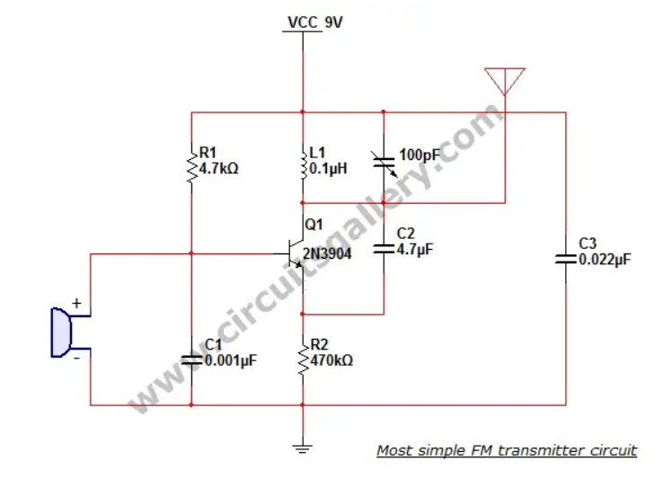

### Components Required for Most Simple FM Transmitter Circuit Diagram

* Power supply (9V)
* Resistors ¼ watt (4.7k Ω; 470Ω)
* Capacitors (0.001µF; 4.7µF; 0.022µF)
* Trimmer capacitor (10-100pF)
* Inductor (0.1µH) (6-7 turns using 26 guage copper wire)
* Transistor (2N3904)
* [Condenser Mic](https://www.circuitsgallery.com/condenser-mic-audio-amplifier-circuit-using-bel-1895-ic/)
* Antenna (Copper wire 20 cm long and 24 gauge)

### Working Principle of Most Simple FM Transmitter Circuit

* A [condenser microphone](https://www.circuitsgallery.com/condenser-microphone-amplifier-schematic-using-bel-1895-ic/) is used to accept the sound signals. Inside the mic, a capacitive sensor diaphragm is present. It vibrates according to the air pressure changes and generates AC signals.
* The inductor L1 and variable capacitor (trimmer) form an oscillating tank circuit along with the transistor 2N3904. It is the common NPN transistor used for general-purpose amplifications.
* As long as the current exists across the inductor coil L1 and the variable capacitor, the tank circuit will oscillate at the resonant carrier frequency for FM modulation. Capacitor C2 acts as negative feedback to the oscillating tank circuit.
* Every FM transmitter circuit requires an oscillator part to generate the radio Frequency (RF) carrier waves. The name ‘Tank’ circuit is derived from the capacity of the LC circuit to store energy for oscillations.
* The input audio signal from the mic is fed to the base of the transistor which modulates the LC tank circuit carrier frequency in FM format.
* The variable capacitor is used to change the resonant frequency for fine adjustment to the FM frequency band.
* The modulated signal from the antenna is radiated as radio waves at the FM frequency band. The antenna is nothing but a simple copper wire 20 cm long and 24 gauge.
* The length of the antenna is very significant in the FM transmitter circuit. Here you can use a 25-27 inches long copper wire as an antenna.

### Design Your Own Inductor Coil for the Simple FM Transmitter Circuit

Our aim is to resonate the inductor at **88-108MHz** band FM frequency. The length, inner diameter, number of turns, etc. are the important factors to be considered while inductor designing. You can design an inductor using the following formula,

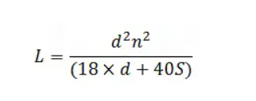

where,

**L** – Inductance of the coil in **µH**  
**d** – Coil diameter in **Inches**  
**S** – Coil length in **Inches** and  
**n** – Number of turns

### [Solved] FM Transmitter is not working | Troubleshooting of FM transmitter circuit

* Firstly, use a battery-operated FM pocket radio to receive the radio signal transmitted via the FM transmitter circuit.
* Secondly, place the FM radio half a meter away from the transmitter and tune it to 80- 108MHz range.
* Then, produce a sound near to the mic, if the tank circuit is properly tuned the sound will be heard in the radio receiver.
* Adjust the shaft of the trimmer and check again whether the sound is clear than the previous case.
* If the sound clarity is fine, stick the inductor coil with glue to avoid further frequency variations.
* Finally, now your best FM transmitter is ready to use.

As a matter of fact, the performance and working principle of a wireless audio transmitter circuit mainly depend on inductor coil specification. Moreover, the value of the variable capacitor is another core contributing factor.

Unquestionably, even a slight change of inductance or capacitor can shift the harmonic frequency from the VHF (88-108 MHz) band.

## 3. BASK or OOK Circuit Using CD4016 | Practical Shift Keying or On-Off Keying Circuit

We are already familiar with Binary Amplitude Shift Keying (BASK) or On-Off Keying (OOK), one of the best digital modulation techniques. In this method, we are going to discuss the amplitude of the carrier that is switched according to the binary data. In this project, binary 1 is represented by a short pulse of light, and binary 0 by the absence of light.

### Circuit Diagram of BASK or OOK Circuit Using CD4016

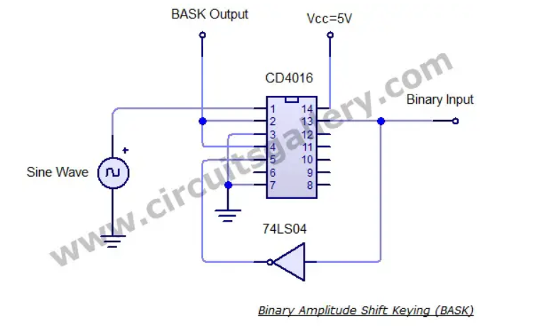

### Components Required for ASK Using CD4016

1. CD4016 IC
2. NOT gate 7404

### Output Waveform of BASK or OOK Circuit

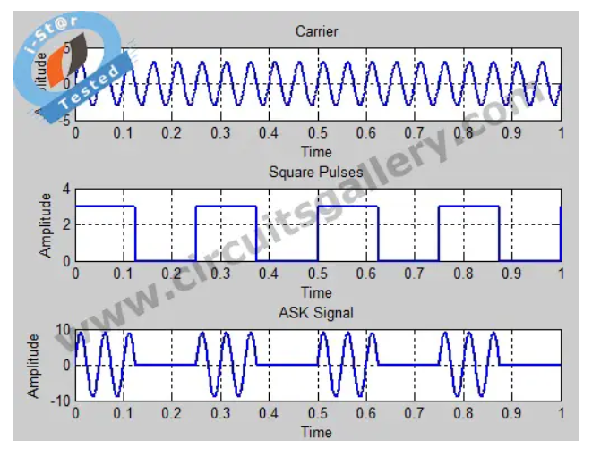

### Working on ASK circuit

* Sine waves can be obtained from a function generator or using an RC phase shift oscillator.
* Two switches inside the quad analog switch CD 4016 are used in the circuit. When the enable input of one gate is high, then the input will appear at the output.

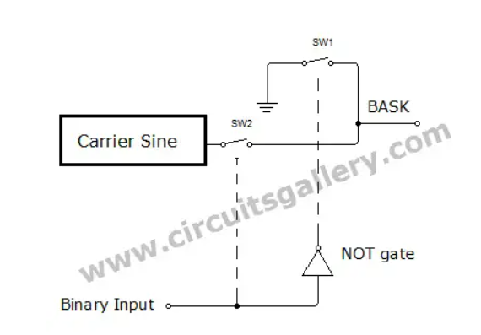

* When the binary data is 1, a sine wave is switched to output because the sine wave is connected to the 1st switch and the binary data is applied to enable the pin (13th pin) of the 1st switch.
* When binary data is 0, the 1st switch is disabled and 2nd switch is enabled using the not gate arrangement.
* The input of the 2nd pin is ground, hence we get 0V for binary 0.
* The output pins of both first and second switches are shorted and the output is taken from it. The [block diagram](https://www.circuitsgallery.com/pulse-width-demodulation-theory-with-block-diagram-and-waveform/) is self-explanatory.

### Components Pin out

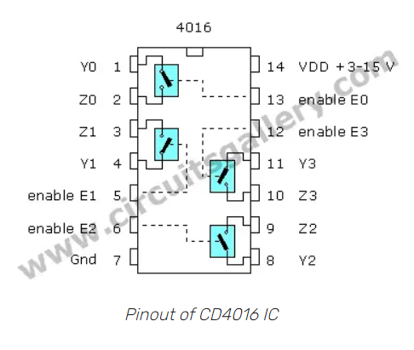

Amplitude Shift Keying modulation and demodulation processes are relatively inexpensive and easy to implement. BASK or OOK circuit using CD4016 can be used to transmit digital data over optical fiber, point-to-point military communications applications, and more.

## 4. Simple FM Transmitter Circuit Using VMR6512 | HI-FI Audio FM Transmitter Module | Long Range, Short Range

There are many devices and systems such as cars, digital FM transmitters, Hi-fi wireless headphones, Conference Broadcasting Systems, Accessories of audiovisual entertainment equipment, and Radio stations that need FM radio transmitter.

You can easily make this FM radio transmitter using the VMR6512. This is a wireless audio transmitter chip that integrates a superior digital signal processor (DSP), matching network, frequency synthesizer, RF power amplifier. It can grasp FM audio modulation without any external components.

However, if you want to transmit your voice directly as FM, then you’ll need a pre-amplifier section with this circuit. Now, let’s learn how to make this digital FM transmitter below.

### Circuit diagram of FM Transmitter Circuit Using VMR6512

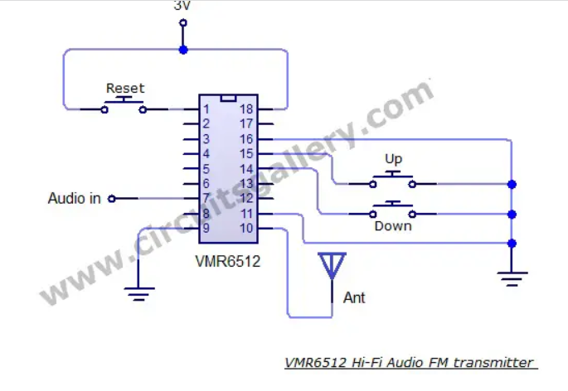

### Components Required

1. VMR6512 Hi-Fi Audio FM transmitter module
2. Push button switch x 3
3. Antenna
4. Audio amplifier

### Constructional Details of An FM Transmitter Circuit Using VMR6512

* Firstly, Construct your [audio amplifier](https://www.circuitsgallery.com/battery-powered-portable-audio-amplifier-circuit-using-tpa2025d1/).
* Then you can directly connect the output of the [Audio amplifier](https://www.circuitsgallery.com/simple-condenser-microphone-mini-audio-amplifier-circuit-schematic/) to the VMR6512 Hi-Fi Audio FM transmitter input (Audio in)

#### Features of VMR6512 Hi-Fi Audio FM transmitter

* Broadcasts sound without any external components.
* Audio frequency processed by DSP, providing high-quality sound.
* We are using synthetic frequency technology, high oscillation frequency stability, and output [power adjustments](https://www.circuitsgallery.com/high-current-adjustable-power-supply-circuit-using-lm317/).
* The frequency range is 88.0MHz to 108.0MHz. The low-end enables extension up to 76.0MHz upon request.
* It can input analog audio or digital audio. VMR6512 possesses external UART interface. You can easily control it with an external CPU or PC machine.
* The IC provides frequency setting UP / DOWN input. So you can and can use it independently.

#### Pin descriptions of VMR6512 IC

* RST Reset the module with high PWL
* RXD control serial input RX
* TXD control serial output TX
* DIN digital audio data input
* DFS digital audio frame synchronized signal input
* DCLK digital audio clock signal input
* RIN analog audio input on the right
* LIN Analog audio input on the left
* GND Ground
* RFOUT RF output
* GND Ground
* NC No connection
* NC No connection
* DOWN Frequency reduction input, each low PWL impulse output frequency decreases 0.1MHz, continuous low PWL repeats every 0.3 seconds.
* UP Frequency increasing input, each low PWL impulse output frequency increases 0.1MHz, continuous low frequency every 0.5 seconds.
* D/A# Audio input digit / analog selection
* NC No connection
* VCC Power input, 2.7-3 .3 V

#### Functions of the Pins as per the Manufactures

**Reset**  
Reset pin set to high PWL will reset the controller, DSP, and frequency synthesizer. After reset, the communication frequency will be 100.0MHz and the power will be 115dBuV. The system begins working at 160ms once the Reset signal becomes lower.  
  
**Analog audio input Rin, Lin**  
Rin and Lin is the analog audio input pin of the VMR6512 module. There is a capacitor in the pin. So the other exterior components are less in terms of requirement. Audio input impedance is approximately 56 kΩ.  
  
Digital audio input interface  
The digital audio input interface consists of SCLK, DIN, and FS. You can set it to I2S, DSP and Left Justified three different formats through commanding and connected without a glitch with almost all the DSP.  
  
UP / DOWN pin  
UP and DOWN pins modify the operating frequency exclusively of the external controller. Each low PWL impulse larger than 0.05 seconds of UP / DOWN pin will make output RF power raise or decrease 0.1MHz. If you stay low PWL, then the operating frequency will change continuously every 0.3 seconds.  
  
RF output  
As the unit has internal matching networks, the RF output signal pin should come in direct connection to the line without any components. We propose that the antenna should use a 1/4 wavelength wire or rod antenna.

### Pinout of VMR6512 Hi-Fi Audio FM transmitter module

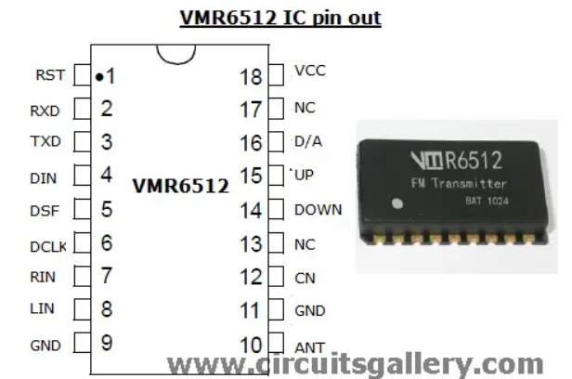

You can build a high-fidelity FM transmitter circuit using VMR6512 for both short and long-ranges. It’s the power of the IC VMR6512 that catches and processes FM signals effortlessly to produce such a magnificent result.

## 5. Amplitude Shift Keying (Ask) Modulation Code in Matlab

Amplitude Shift Keying is one of the basic types of digital modulation techniques. In ASK, the amplitude level of the carrier signal is switched according to the binary information, while keeping the phase and frequency fixed. Here you’ll learn the ASK simulation using a simple Matlab function.

**Matlab Program for ASK**

clear all;

clc;

close all;

F1=input(‘Enter the frequency of carrier=’);

F2=input(‘Enter the frequency of pulse=’);

A=3;%Amplitude

t=0:0.001:1;

x=A.*sin(2*pi*F1*t);%Carrier Sine wave

u=A/2.*square(2*pi*F2*t)+(A/2);%Square wave message

v=x.*u;

subplot(3,1,1);

plot(t,x);

xlabel(‘Time’);

ylabel(‘Amplitude’);

title(‘Carrier’);

grid on;

subplot(3,1,2);

plot(t,u);

xlabel(‘Time’);

ylabel(‘Amplitude’);

title(‘Square Pulses’);

grid on;subplot(3,1,3);

plot(t,v);

xlabel(‘Time’);

ylabel(‘Amplitude’);

title(‘ASK Signal’);

grid on;

### Generated Ask Signal

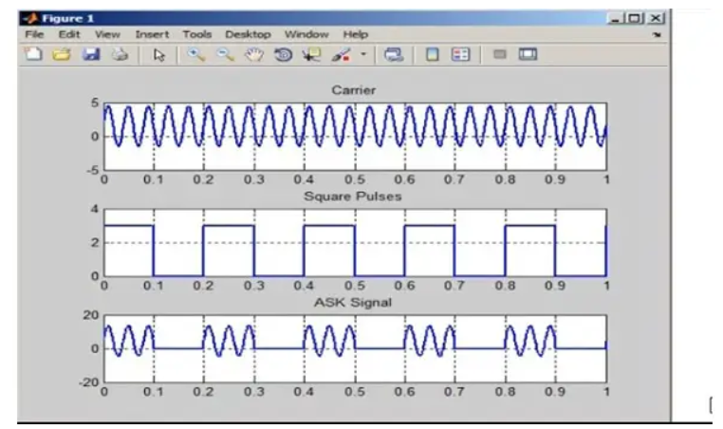

Here the full Matlab code of ASK modulation is provided. You can use this code in any recent version of MatLab for generating an ASK modulation signal.

## 6. Matlab Code for Frequency Modulation (FM) With Modulation Index

Do you know how to generate frequency modulation (FM) in MATLAB? Before that, you must know what FM (frequency modulation) is.

In FM, the frequency of the carrier signal having a high frequency is varied in accordance with the instantaneous amplitude of the modulating signal having a low frequency. Frequency-modulated signals are widely used in television and radio transmission systems. FM signals can be easily plotted using simple MATLAB functions.

The MATLAB code is shown below, the use of particular code is also given as commented form ( %Comment field ).

You can provide two input frequencies and a modulation index in this given Matlab program. Let’s learn more details about this transmission system below.

### Matlab Code for Frequency Modulation

clc;  
clear all;

fm=input(‘Message Frequency=’);  
fc=input(‘Carrier Frequency=’);  
mi=input(‘Modulation Index=’);  
t=0:0.0001:0.1;  
m=sin(2*pi*fm*t);  
subplot(3,1,1);  
plot(t,m);  
xlabel(‘Time’);  
ylabel(‘Amplitude’);  
title(‘Message Signal’);  
grid on;

c=sin(2*pi*fc*t);  
subplot(3,1,2);  
plot(t,c);  
xlabel(‘Time’);  
ylabel(‘Amplitude’);  
title(‘Carrier Signal’);  
grid on;

y=sin(2*pi*fc*t+(mi.*sin(2*pi*fm*t)));%Frequency changing w.r.t  
Message  
subplot(3,1,3);  
plot(t,y);  
xlabel(‘Time’);  
ylabel(‘Amplitude’);  
title(‘FM Signal’);  
grid on;

Hope the above-mentioned Matlab program was helpful to you. To find out more codes, check to ASK, [PWM](https://www.circuitsgallery.com/pwm-and-triangular-wave-generators/), AM, etc.

## 7. PSK Modulation Code in MATLAB | Phase Shift Keying

You may be already familiar with Binary Phase shift keying (BPSK). It is one of the basic modulation schemes in which the phase of the carrier signal is varied or switched according to the input message pulses.

When the modulation input is at logic 1, a finite number of cycles of a sinusoidal signal are transmitted and when the input is at logic 0, the phase of the sinusoidal is changed. We have already discussed in detail binary phase-shift keying and applications of PSK modulation above. Now, let’s learn about this Matlab program for [BPSK modulation](https://www.circuitsgallery.com/binary-phase-shift-keying-bpsk-modulation-using-cd4016/) below.

### Matlab Program for PSK / Matlab Code for PSK

clear all;

clc;

close all;

A=5;

t=0:.001:1;

f1=input("Carrier Sine wave frequency =");

f2=input("Message frequency =");

x=A.*sin(2*pi*f1*t);%Carrier Sine

subplot(3,1,1);

plot(t,x);

xlabel("time");

ylabel("Amplitude");

title("Carrier");

grid on;

u=square(2*pi*f2*t);%Message signal

subplot(3,1,2);

plot(t,u);

xlabel("time");

ylabel("Amplitude");

title("Message Signal");

grid on;

v=x.*u;%Sine wave multiplied with square wave

subplot(3,1,3);

plot(t,v);

axis([0 1 -6 6]);

xlabel("t");

ylabel("y");

title("PSK");

grid on;

### Generated PSK Signal

Carrier Sine wave frequency =10  
Message frequency =2

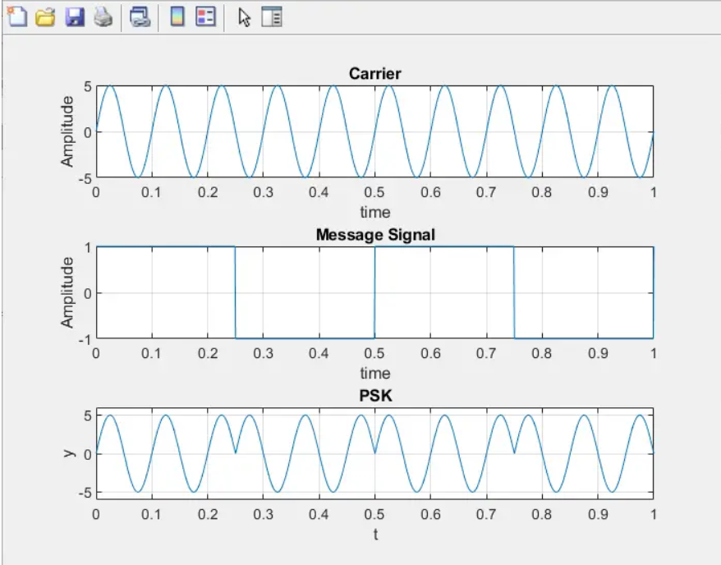

In addition to the PSK modulation code in MATLAB, we have also come up with MATLAB programs for other modulation processes like FSK.

## 8. MATLAB Code for AM with Modulation Index

We all know that the AM is a method of transmitting signals, such as sound or digital information, in which the amplitude of the carrier wave is changed according to the message signal. It is widely used in the electronic communication field. But do you know how to generate Amplitude modulation (AM) using MATLAB?

If not then don’t worry, because the [plotting of AM signals using MATLAB](https://www.circuitsgallery.com/how-to-plot-a-2d-function-in-matlab/) is very easy. Here we are simply adding the carrier amplitude with the message signal to obtain an AM signal. Then the instantaneous amplitude of the carrier gets altered with respect to the modulating signal. Thus, the carrier amplitude varies according to the baseband signal (message signal). The detailed process of generating the **Amplitude Modulation** (AM) using Matlab is described below.

### Mathematical Representation of Am Signal

If the message signal is represented by,

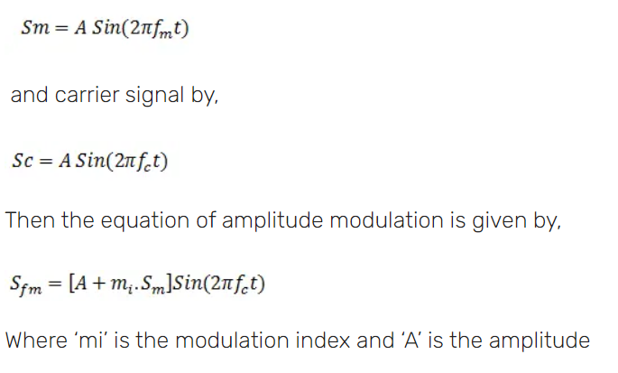

### Matlab Codes

clc;

clear all;

close all;

t=0:0.001:1;

set(0, defaultlinelinewidth', 2);

A=5;%Amplitude of signal

fm=input('Message frequency=');%Accepting input value

fc=input('Carrier frequency=');%Accepting input value (f2>f1)

mi=input('Modulation Index=');%Modulation Index

Sm=A*sin(2*pi*fm*t);%Message Signal

subplot(3,1,1);%Plotting frame divided in to 3 rows and this fig appear at 1st

plot(t, Sm);

xlabel('Time');

ylabel('Amplitude');

title('Message Signal');

grid on;

Sc=A*sin(2*pi*fc*t);%Carrier Signal

subplot(3,1,2);

plot(t,Sc);

xlabel('Time');

ylabel('Amplitude');

title('Carrier Signal');

grid on;

Sfm=(A+mi*Sm). *sin(2*pi*fc*t);%AM Signal, Amplitude of Carrier changes to (A+Message)

subplot(3,1,3);

plot(t, Sfm);

xlabel('Time');

ylabel('Amplitude');

title('AM Signa');

grid on;

### Generated AM Signal

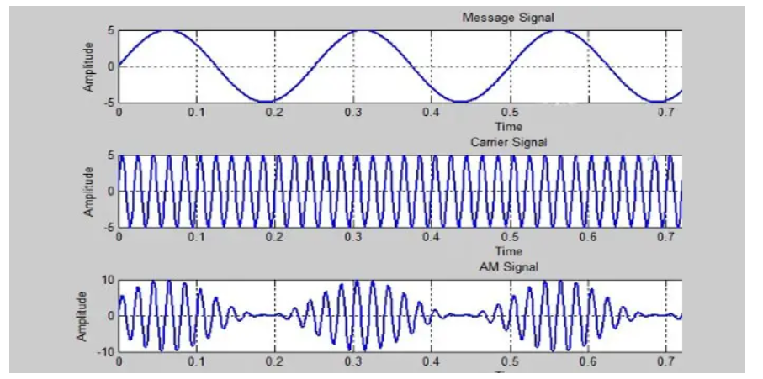

The uses of this particular MATLAB code are also given in the commented form (%comment field). The program is capable of accepting two input frequencies and modulation indexes from the keyboard.

## Conclusion

Here we’ve discussed the development process of different types of transmitters along with the basic principles, diagrams, and simulations. To understand these transmitters you’ll only need to understand the basic concept of the multivibrator. We’ve demonstrated how you can use the Matlab code and functions for these transmitters. For this, you’re provided with the complete Matlab codes in this article. So, we hope, now you’ve understood the modulation system in transmitters after reading this article, and you can now make your own circuit for your school projects by implementing these functions described above.

# FM Modulation/de-modulation Circuit

I got the idea for this circuit from one of my professors. That design wasn't meant for passing frequencies high enough to be able to pass an audio file, e.g. 500Hz+, so I built this by modifying the carrier and signal frequencies, using only the [Digilent Analog Discovery](http://digilentinc.com/Products/Detail.cfm?NavPath=2,1040,1043&Prod=ANALOG-DISCOVERY) and the [Analog Parts Kit](http://digilentinc.com/Products/Detail.cfm?NavPath=2,1040,1066&Prod=APK). It should be noted that this circuit is primarily for educational purposes. Also note that there is no radio transmission here either. FM doesn't necessarily mean radio waves have to be involved.

Throughout this Instructable I will be going through some of the functions and features of the Analog Discovery, but it will not be an exhaustive tutorial.

## Step 1: Parts and Tools

[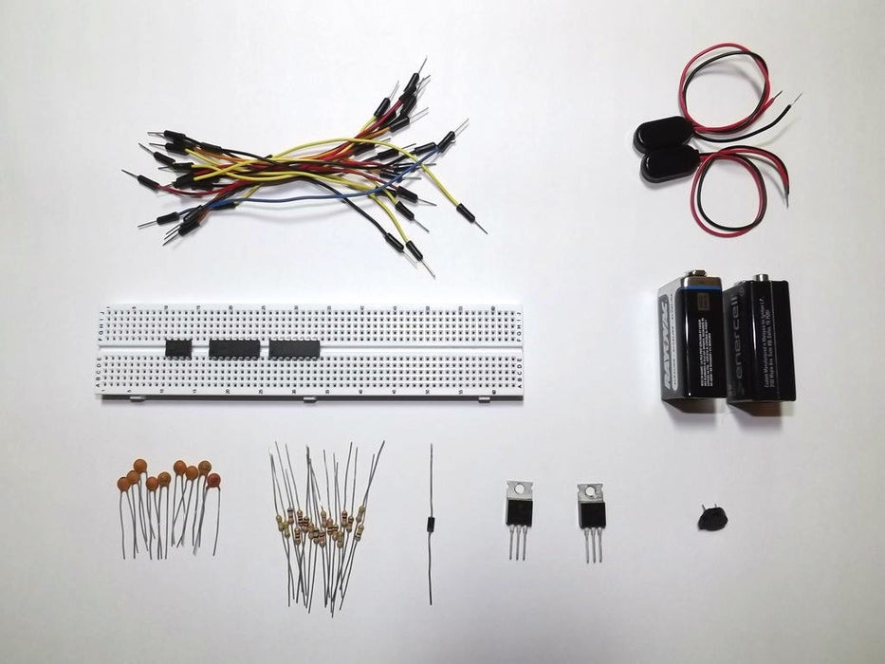](https://content.instructables.com/FQ2/9MZK/HWRC6WMT/FQ29MZKHWRC6WMT.jpg?auto=webp&frame=1&fit=bounds&md=854cac6d33812da9bcab43ad4b7b42ec)

[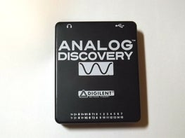](https://content.instructables.com/FOT/PFX3/HWRC6WOA/FOTPFX3HWRC6WOA.jpg?auto=webp&frame=1&fit=bounds&md=3c46302dc3d245cd620d8ac87c19672b)

[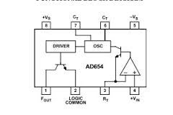](https://content.instructables.com/FMA/1047/HWNU6JJC/FMA1047HWNU6JJC.jpg?auto=webp&frame=1&fit=bounds&md=903b07a80a48335b257c38079f1c1a84)

All of the parts listed below are provided in the [Analog Starter Kit](http://digilentinc.com/Products/Detail.cfm?NavPath=2,1040,1066&Prod=APK), except for the 9V batteries and clips. They should also be available through various online suppliers, local shops, or the salvage bin on your workbench.

The Parts:

- 2 OP482 quad op-amps ([datasheet](http://www.analog.com/static/imported-files/data_sheets/OP282_482.pdf))

- AD654 voltage to frequency converter ([datasheet](http://www.analog.com/static/imported-files/data_sheets/AD654.pdf))

- 9 ceramic capacitors: 2 - 39pF (39), 2 - 100pF (101), 2 - 1nF (102), 2 - 4.7nF (472), 1 - 10nF (103)

- 17 carbon film resistors: 1 - 68, 3 - 1k, 1 - 6.8k, 3 - 10k, 1 - 20k, 1 - 47k, 2 - 100k, 5 - 470k

- 1 1N4001 rectifier diode

- 1 speaker

- solderless breadboard

- jumper wires

(optional)

- 1 TIP31C NPN BJT

- 1 TIP32C PNP BJT

- 2 9V batteries with clips

The Tools:

- [Digilent Analog Discovery](http://digilentinc.com/Products/Detail.cfm?NavPath=2,1040,1043&Prod=ANALOG-DISCOVERY)

- [Waveforms](http://digilentinc.com/Products/Detail.cfm?NavPath=2,66,849&Prod=WAVEFORMS) software (free but required to run the Analog Discovery)

- short, free [.wav](http://www.wavsource.com/) file download.

Pin-out diagrams are included for the OP482 quad op-amp and AD654 voltage to frequency converter, also called a voltage controlled oscillator or VCO.

## Step 2: Designing

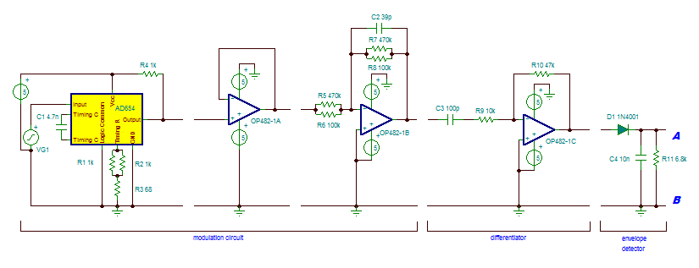

The schematic for this can be daunting to say the least. When I first started working with it, I got lost all the time and had to keep going back over it again and again. You'll notice in the schematic that there are breaks throughout the design. Each of those breaks represents a good stopping point for verifying the circuit function. Take it slow and add one section at a time. The OP482 ICs are quad op-amps, meaning four op-amps on one piece of silicone. That can make it tricky to hook everything together as components can get crowded. This project can be built using individual op-amps if that is easier for you, but I would recommend using the OP27 and not the LM741. The LM741 should work, but I have had problems with it when it comes to needing fast, reliable response times. The specs are just a bit too slow for some applications, specifically the skew rate when you need high gain at a relatively high frequency.

For clarification the schematic image is broken up. Point ***A***matches to point ***A***, ***B*** with ***B***.

## Step 3: Frequency Modulation

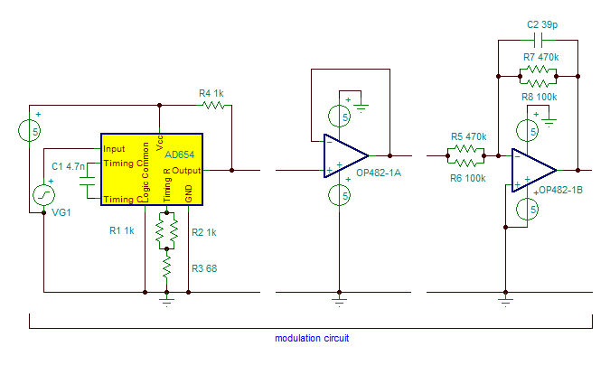

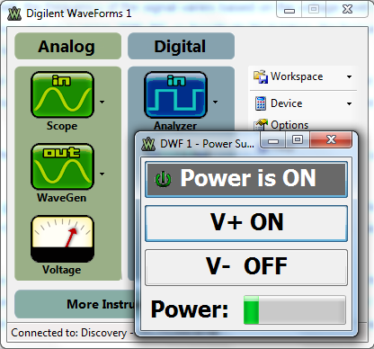

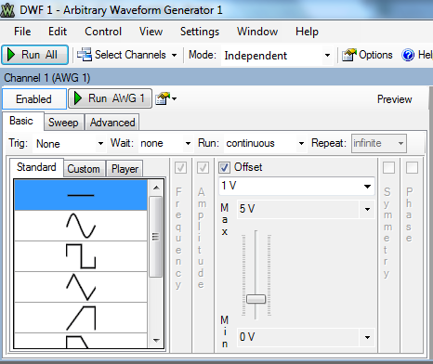

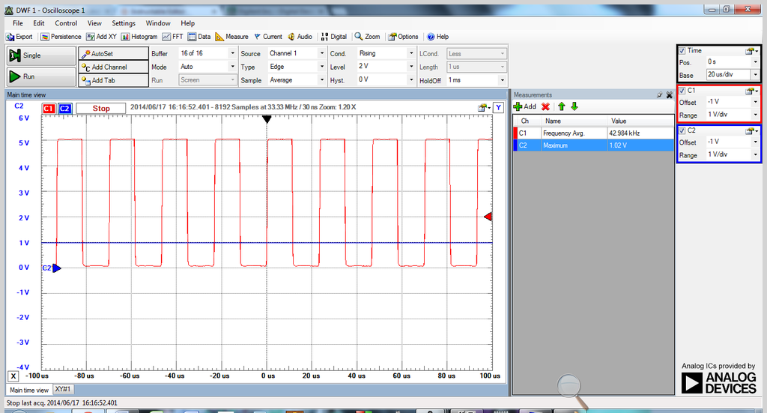

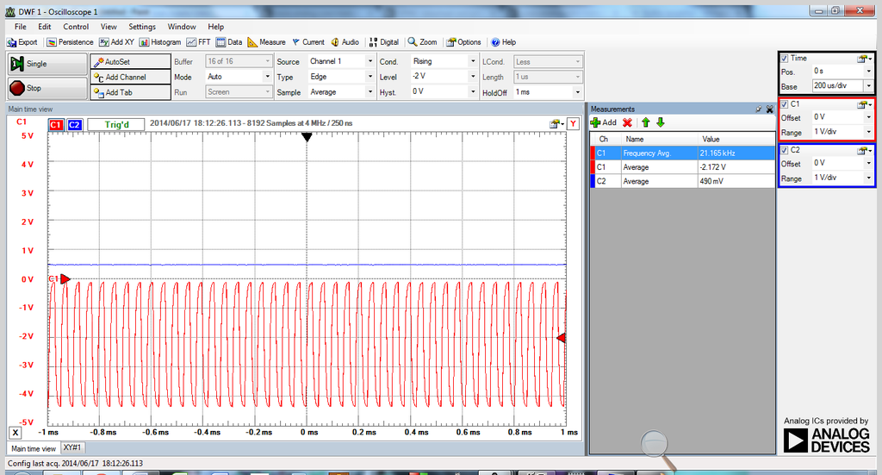

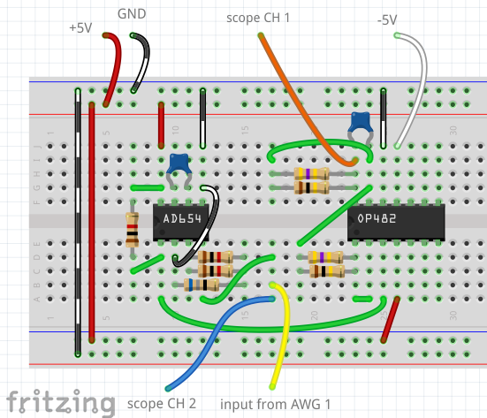

I won't go into the details of FM or AM technology too much here. I would refer you to [Wikipedia](http://en.wikipedia.org/wiki/Frequency_modulation) for that (note the animation on the right side of the page). In a nutshell, for FM signals, the frequency of the signal varies based on the voltage level coming in. So a high voltage gives a high frequency, and vice versa. With AM, the frequency stays the same, but the amplitude goes high or low depending on the input voltage. As you will see, this circuit actually uses both.

The higher frequency signal is the carrier frequency, while the original signal is the data that you want to relay. We will use the data signal to modulate a much higher frequency carrier wave. Later we will filter out the carrier and recover the data.

The first three sections of the schematic are the modulation circuit. We first modulate the carrier wave, then amplify it. The AD654 changes the frequency of the output based on the voltage level of the input. The timing resistors and capacitors give a base frequency value for the IC to work with based on the equation found in the datasheet.

Using pages 1 and 4 of the [datasheet](http://www.analog.com/static/imported-files/data_sheets/AD654.pdf) for the AD654, connect the components as shown. Note that 'Vs' indicates voltage supply, so '+Vs' is +5V and '-Vs' is ground. '+Vin' is the signal coming from the Analog Discovery AWG Channel 1 pin, labeled 'input' in the schematic.

Turn on the Voltage function from the Waveforms main window (image 2). Click V+ to 'ON', connect the red V+ wire from the Discovery header to pin 8 on the AD654, then turn it on. Using the Discovery's AWG channel 1, output a 1VDC signal (image 3) and plug it into pin 4 of the AD654. You should get a readout on the scope like image 4.

Next we add the first OP482. The first part is a simple [voltage follower or buffer](http://en.wikipedia.org/wiki/Voltage_follower). Since op-amps are active components, we will get a boost in current from this part. Next we add an active [low-pass filter](http://en.wikipedia.org/wiki/Low-pass_filter) set to cutoff at approximately 50kHz, which is high enough to allow our signal to pass through but low enough to filter out random high frequency noise we don't want. When connecting the OP482, connect the Discovery's red V+ wire to pin 4 and the white V- wire to pin 11. Turn on the power supply (like in image 2, but both channels this time) before turning on AWG 1 with the signal. Set AWG 1 to an amplitude of 500mV this time. Your scope should look something image 5.

## Step 4: Differentiator and Envelope Detector

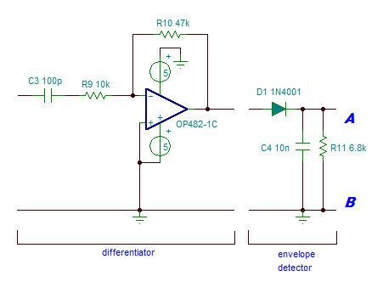

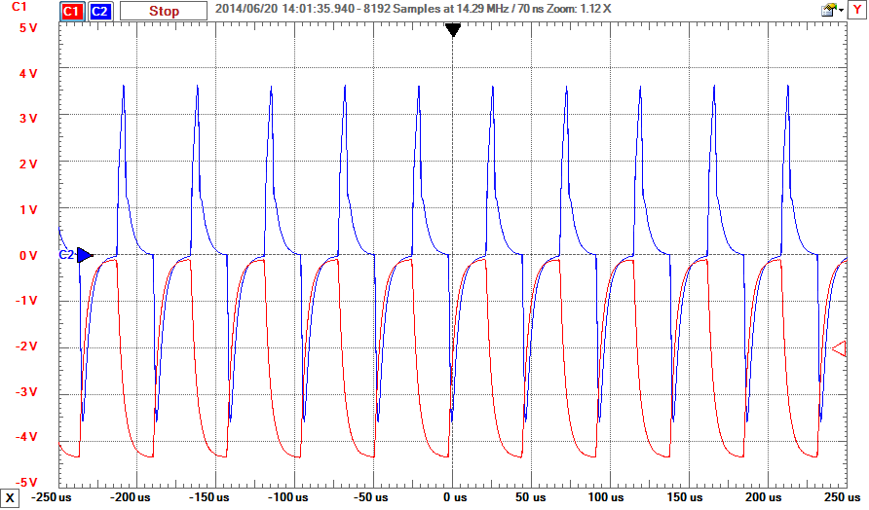

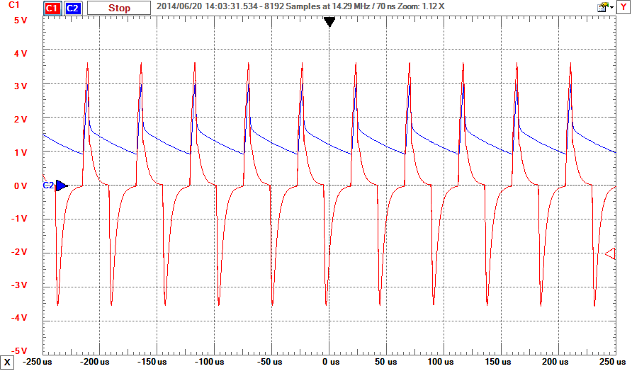

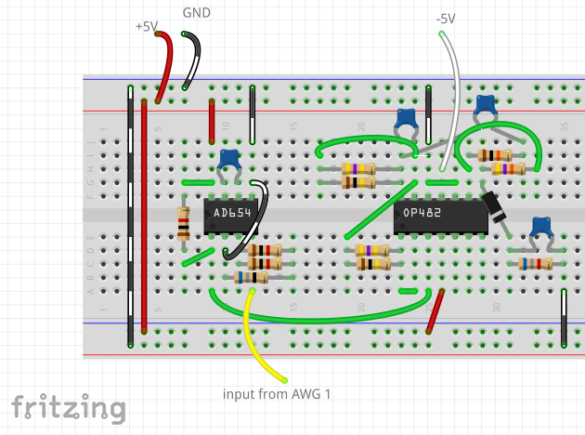

The theory behind most of these parts is a bit much to get into here. Again, check out wikipedia for the [differentiator](http://en.wikipedia.org/wiki/Differentiator) (note that this one is active because of the op-amp) and the [envelope detector](http://en.wikipedia.org/wiki/Envelope_detector) explanations. In short, the differentiator, believe it or not, differentiates the signal (think calculus and it makes total sense). As the input signal rises or falls quickly (high frequency), the output amplitude increases. As the input rises or falls slowly (low frequency), the output amplitude decreases closer to 0. This has the interesting effect of turning the FM signal into an AM signal. See the o-scope display in image 2 for a comparison (scope CH 1 to pin 14 of the OP482 and CH 2 to pin 8).

The envelope detector detects only the top edge of the signal, so as the amplitude rises and falls, so will the signal coming out of the envelope detector. See image 3 for an example (CH 1 to pin 8 of OP482 and CH 2 to cathode of 1N4001 diode).

## Step 5: Filtering

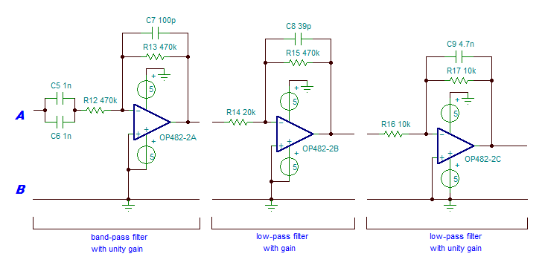

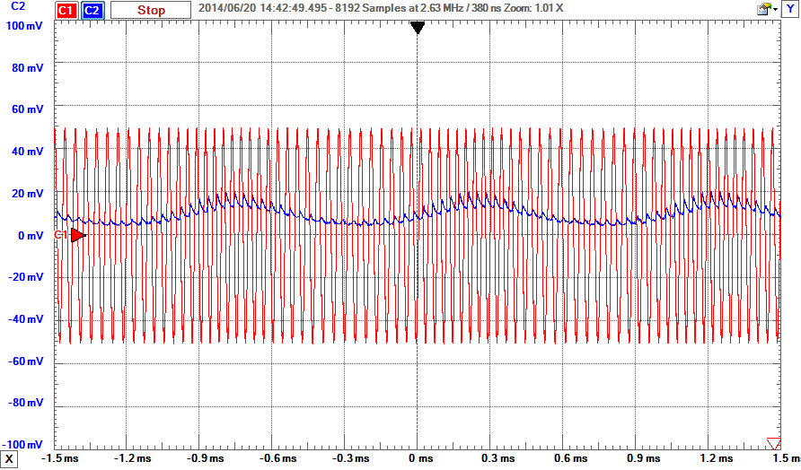

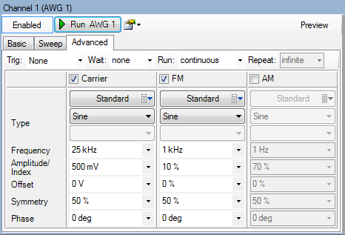

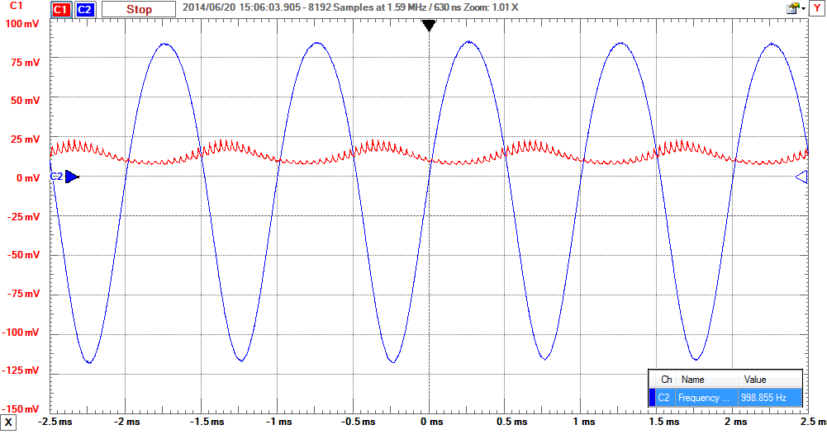

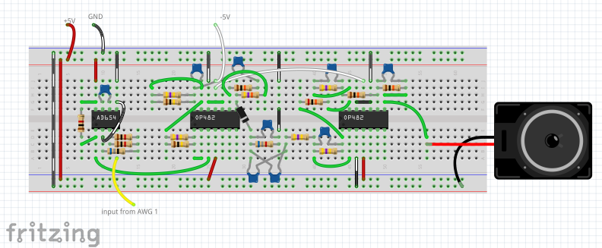

The signal from the envelope detector doesn't have much amplitude and contains quite a bit of noise. So we add several filters to both clarify and boost the signal. Look at the o-scope display in image 2. The red CH 1 signal is a 25kHz carrier with a 1kHz modulation frequency, amplitude of 500mV and index of 10%. These settings are all under the advanced tab on the Analog Discovery AWG tool (see image 3) if you would like to generate the signal yourself. This signal then is inserted into the input of the differentiator, bypassing the modulation circuit for now. The blue CH 2 is the output of the envelope detector, before any filtering. Do you see the scale on the left of the display in image 2? Each division is 20mV for CH 2. Most scopes will let you choose different scales for each channel, and here the scale for CH 1 is 200mV/div, larger by a factor of 10. With these two signals on a scale of 200mV/div, you would barely be able to see the output of the envelope detector because it is so weak. You can also see the noise in the signal as well in image 2. We need to filter that out and amplify the signal by a fair amount. We will also be running the signal through a band-pass filter to only allow audible frequencies between 200Hz and 2kHz to pass.

The first part is the [band-pass filter](http://en.wikipedia.org/wiki/Band-pass_filter). It allows only a small range of frequencies to pass through, and in our case 200Hz to 2kHz is more than enough. Note that because the resistors match, there is no gain here, only filtering. We don't want to amplify noise, so let's filter it out first.

After the band-pass filter we have two [low-pass filters](http://en.wikipedia.org/wiki/Low-pass_filter), the first with gain of approximately 23.5 and cutoff of about 8.6kHz, and the second with unity gain of 1, which means no amplification, and cutoff of about 3.4kHz. Even after the band-pass filter we still have some noise from the carrier wave (filters aren't perfect after all) and the signal is weak. We filter out noise above 8.6kHz and then amplify it 23.5 times. Yep, it's high but it needs it (you can change it by changing the resistor ratio. Click the low-pass filter link above for the equation). The second low-pass filter then further cleans up that signal by filtering noise above 3.4kHz, which is higher than our target range of 200Hz-2kHz, so we're good. The second filter is not absolutely necessary, but it did make a difference in the end.

Image 4 shows the difference in the signal between the output of the envelope detector and the output of the last filter. The scale is not exactly the same as before, but the data was just outside of range so I shrunk it down a little bit. Did you notice the measurement window at the bottom right? That's the 1kHz modulation value we saw in the settings in image 3 above. It's not a perfect sine wave, but it's a far sight cleaner than it was before, and it's good enough that you won't notice the difference.

If you don't want to add the class B amplifier, you're done here. Otherwise, get yourself some 9V batteries and turn the page.

## Step 6: Amplifying the Signal

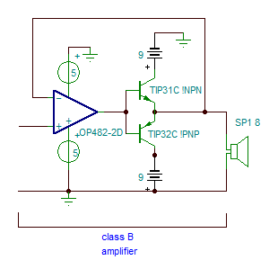

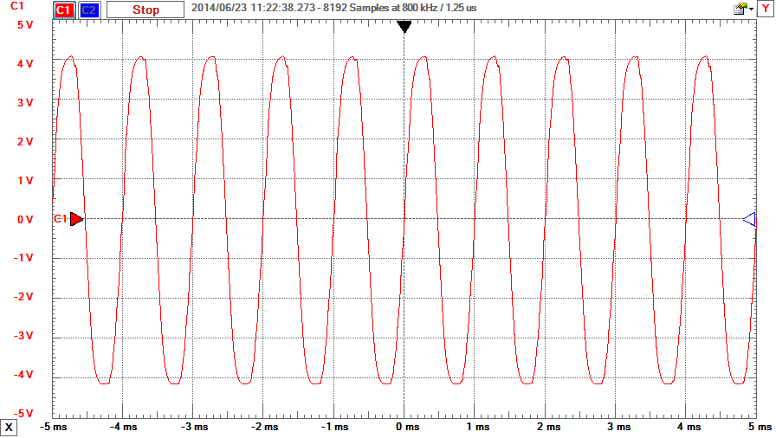

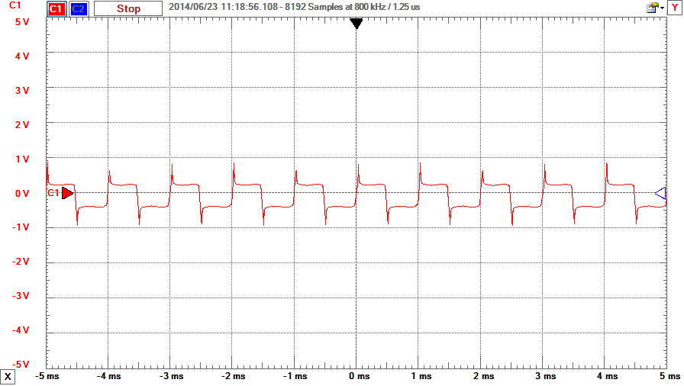

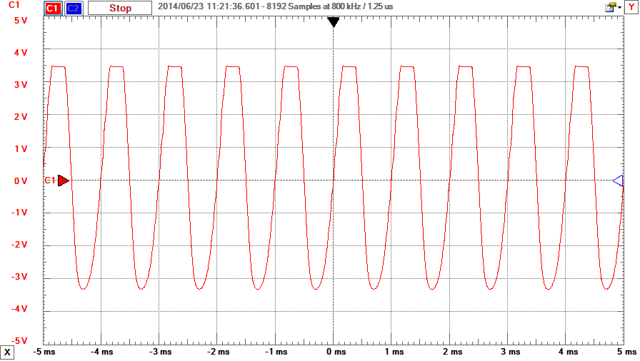

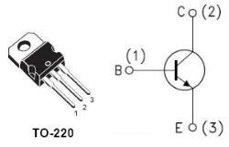

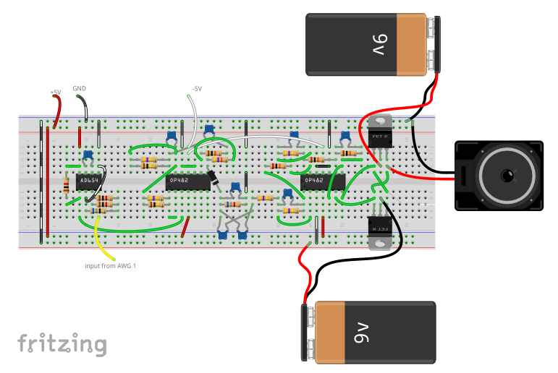

The 9 V batteries and connectors are not included with the Analog Parts Kit, and it is not absolutely necessary to amplify the signal coming from the last low-pass filter. However, as you can see from comparing images 2 and 3, the signal will clip when you add the speaker and form more of a square wave than a sine wave. A small 8-Ohm speaker will clip even more. This happens because the speaker itself also has a transfer function that must be accounted for, which is a fancy way of saying that it is trying to draw too much current at peak voltage, so it clips the voltage. It will actually sound louder, but won't be as clear. Adding the amplifier allows more current to be available and that allows the voltage level at the speaker match the output level at the last filter. Image 4 shows the signal with the amplifier in place and the speaker attached. The difference is minimal this time. I've used this on a 4-inch computer speaker I salvaged and even a 6-inch woofer and they all worked with this amplifier. Just remember that larger speakers require more current so you will drain your batteries faster.

When putting the BJTs on the breadboard it is very easy to get the pins mixed up. I've built this circuit, start to finish, at least half a dozen times, and I still did it. Again. I've included the pin-out diagram for them (they have the same B/C/E pin assignments), so good luck.

## Step 7: Testing

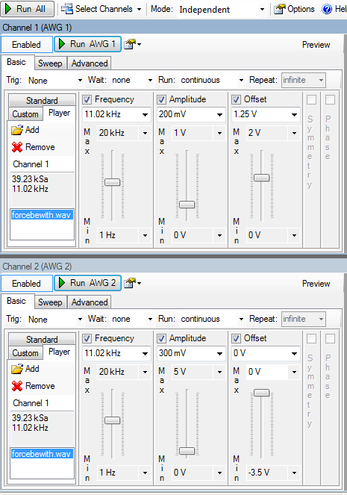

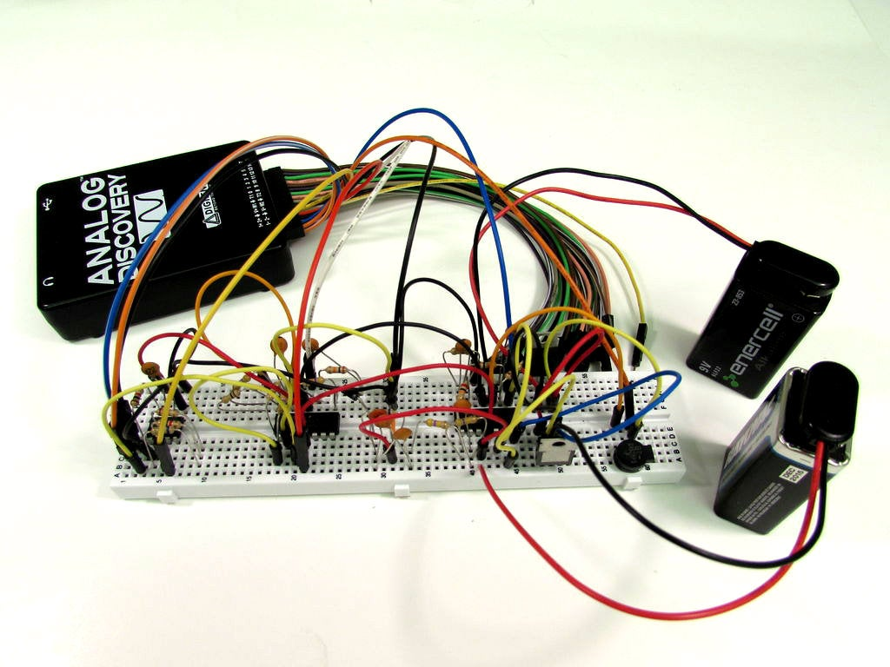

Now let's do some testing to verify. If you haven't yet downloaded a [short .wav file](http://www.wavsource.com/), do so now. Go into the AWG tool settings and check both channels to turn them both on. Click on the 'player' tab, then on 'add'. A window will come up to allow you to find the downloaded .wav file. Double click on it to load it. Notice the playback frequency in the window to the left? My file is set at 11.02kHz. For now, set the AWG channels to playback at this frequency. You won't break anything if you change it, it just changes the playback speed of the file. Load the file for both AWG channels. There are notes on the image that will help clarify this step.

Set the channels according to image 1, making sure that the offset for CH 1 is 1.25V. It will make a big difference and took me a while to troubleshoot the first time. The amplitude (volume) settings are not super critical, but remember that we are amplifying the signal by quite a lot in the circuit, so start smaller and work your way up as desired.

Start with CH 2 on the AWG and plug the yellow/white wire directly into the speaker, bypassing the entire circuit. This way you can hear the file playback on the speaker before passing it through the circuit. Once you have it playing on the speaker using CH 2, plug CH 1 into pin 4 of the AD654. Unplug AWG CH 2 from the speaker and connect the output of the class B amplifier to the speaker. You should hear the same playback either way.

And there you have it. Please don't hesitate to ask questions, either in the comments below or PM. Have fun building!

# Circuit Design: How to Demodulate AM Signal

The amplitude modulation is the simplest modulation technique among the wide verity of modulation techniques in use. In this technique the amplitude of a high frequency signal is varied corresponding to the variation in the amplitude of the low frequency modulating signal. The amplitude modulation of a high frequency signal is easy to achieve and the demodulation is also less complex compared to other techniques. The high frequency signal which is modulated to carry the low frequency audio signals are called ‘carrier frequency’ since they are used to carry the message signal to distant places with the help of wireless transmission devices. The audio signals used for modulation is called ‘modulating signal’ or ‘message signal’ or ‘base band signal’.

The demodulation of an AM wave can be done with only few components and unlike most of the demodulation technique there is no synchronization required between the modulator and demodulator circuits. The message signal appears as an envelope over the amplitude of the carrier wave and the demodulator make use of this to extract the modulating signal from the carrier and hence the technique of AM modulation is called envelope detection.

This article demonstrates how to generate an Amplitude Modulation (AM) and demodulate the same wave to get the original modulating wave. The AM wave is generated based on the circuits explained in article on AM modulation.

**DESCRIPTION:**

The AM demodulation is done using a low pass filter which can filter out the high frequency carrier from the AM wave in such a way that only the envelope of the carrier wave appears at the output of the filter. The amplitude of the filtered wave has variations corresponding to the amplitude of the modulating low frequency signal.

To get a better filtering using the Low pass filter the carrier frequency must be as large as possible and hence the carrier frequency generator circuit explained in the article AM modulation has to be modified for a very high frequency carrier signal. The only change that is required is the value of the capacitors C1 and C2 which determines the carrier frequency generation. The circuit used for generating the sine wave frequency is given below:

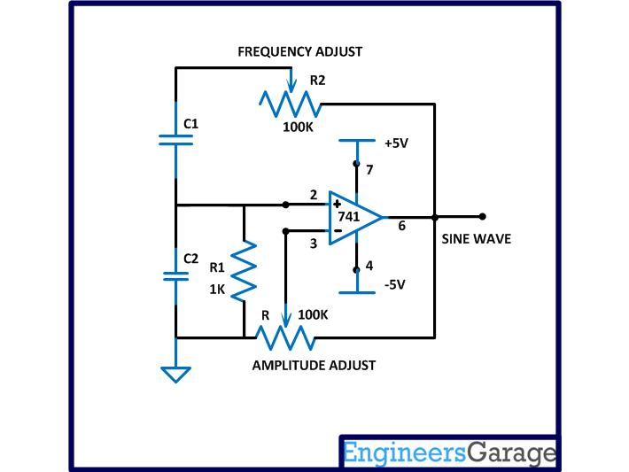

Fig. 1: Circuit Diagram Of Sine Wave Frequency Generator

The value of the resistance R, R1 and R2 are kept same as explained in the article AM modulation. Now the frequency can be calculated using the equation:

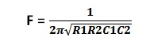

The value of R1 is kept the same as 1K but the value of the resistance R2 can be varied. As the value of the R2 decreases the output frequency of the circuit increases. As it is mentioned in the article AM modulation that the minimum value of the R2 which produces the highest stable frequency is around 130 ohms. In this project to increase the carrier frequency at least 10 times that achieved in the previous project the value of C1 and C2 is reduced to 10 times than that used in the previous AM modulation project. Hence the maximum carrier frequency can be calculated using the frequency equation as shown below:

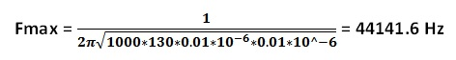

The message frequency or modulating frequency generator circuit is kept the same as discussed in the article AM modulation. The following image shows the carrier wave and the message wave displayed in a dual-channel CRO.

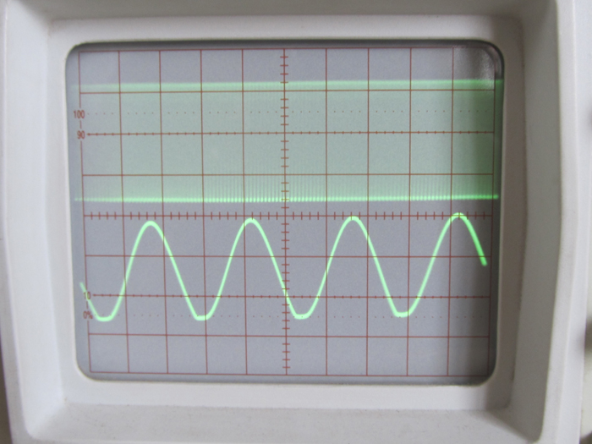

Fig. 2: Carrier Wave And Message Wave Displayed On CRO

The modulation is controlled in this project by some adjustment on the input potentiometer and also with the introduction of a 100K ohm resistor. The carrier signal is now fed through the N-channel from drain to source other than from the source to drain as in the previous project. The output can now be taken from the drain end of the FET where the internal channel modulation by the gate signal is more pronounced. The modified AM modulator circuit and the image of the circuit wired in the breadboard are shown below:

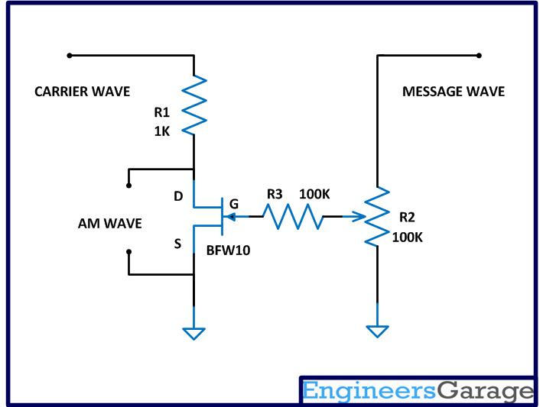

Fig. 3: Circuit Diagram Of Modified AM Modulator

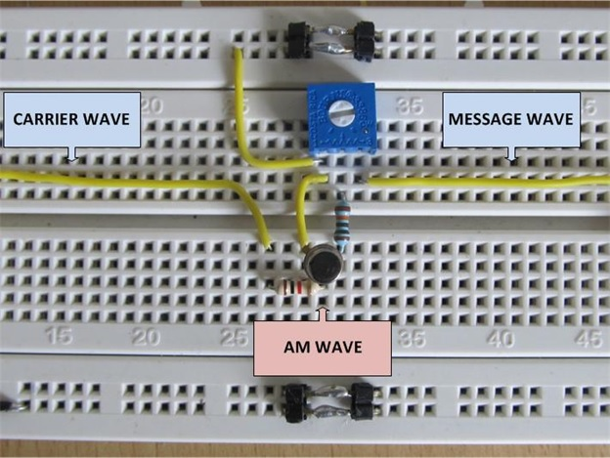

Fig. 4: Modified AM Modulator Circuit On Breadboard

The AM wave is displayed along with the original modulating wave using a dual channel CRO as shown in the following image:

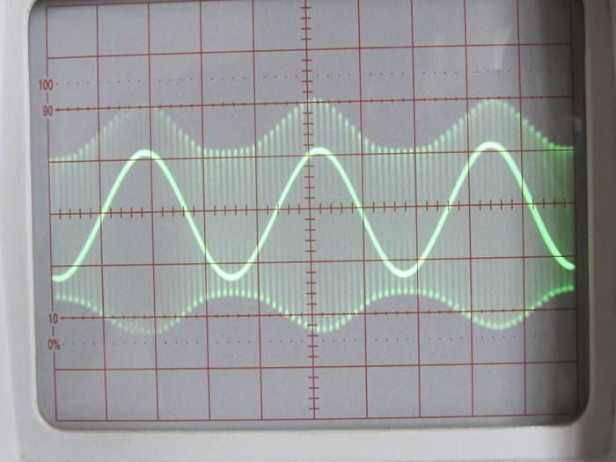

Fig. 5: AM Wave with Original Modulating Wave Displayed on CRO

The low frequency wave at the center is the message wave and the less bright high frequency wave is the modulated carrier wave. The amplitude of the message wave has been reduced significantly using the potentiometer R2 before applying to the FET so that it won’t over modulate the entire amplitude of carrier wave. The following image shows the waveform that appears at the input and output of the FET modulator.

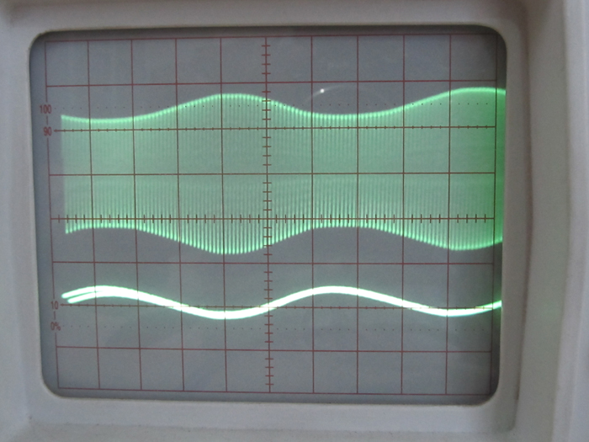

Fig. 6: Input And Output Waveform Of FET Modulator On CRO

## Demodulation Steps

DEMODULATION STEPS

The demodulation of an AM wave is done using three basic steps which are listed below:

   1)  Rectification

   2)  Low pass filtering

  3) Amplification

The AM wave in most of the cases will be a sine wave with both the half cycles and the Rectification is a process through which either one of the half cycles is eliminated so as to make the AC wave to a DC voltage with high frequency ripples and varying amplitude. The amplitude of the DC voltage still contains the variations which have been there in it before the rectification.

The high frequency ripples are eliminated using a filter circuit making the DC voltage smooth and continuous however maintaining the low frequency variations in the amplitude. The output of the filter circuit resembles the original modulating message wave. The demodulation is almost complete with the filter circuit but to use the demodulated signal for some useful purpose one more step has to be performed.

The output of the filter circuit is very small in amplitude and the noise will be so much that the Signal to Noise Ratio (SNR) is very low. To increase the amplitude of the demodulated signal and to improve the SNR, the amplification of the demodulated signal is necessary. The following section discusses the demodulation steps in detail.

Step:1 Rectification

In this project a simplest diode rectifier is used to rectify the AM wave. The circuit diagram used in this project and the image of the circuit wired in the bread board is shown in the following figure:

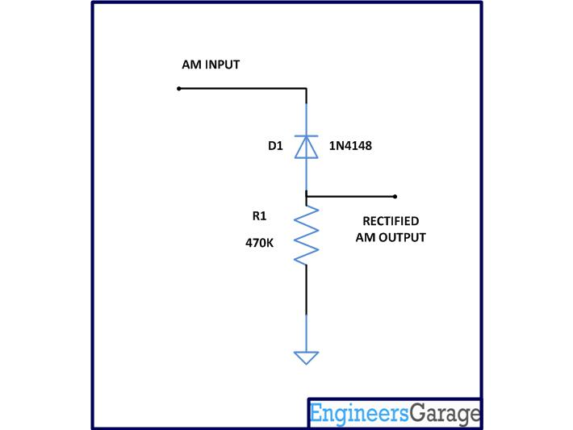

Fig. 7: Circuit Diagram Of Rectifier

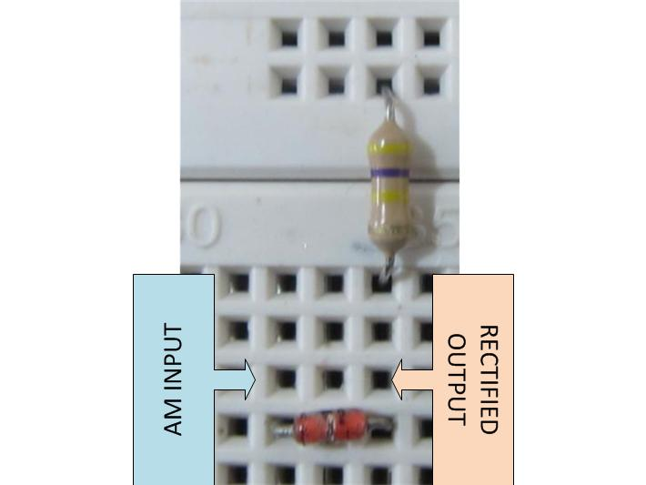

Fig. 8: Rectifier Circuit Wired On Breadboard

The circuit uses a germanium diode which has a cut in voltage of 0.3 volts which is less than that of the silicon diodes. The germanium diode 1N4148 has a very good high frequency response also when compared to the silicon diodes and hence perfect for the rectification of high frequency AM waves.

A high valued resistor of 470K is used to connect the diode to the ground of the circuit to complete the conduction path for the negative half cycles of the AM wave to ground, but without affecting the amplitude due to loading effect.

Simply the negative half cycles only flows through the diode and resistor and they can be taken out across the resistor. Thus the output of the rectifier circuit will be a DC voltage with amplitude varying high frequency ripples. The following image is the waveform at the output of the rectifier displayed in the CRO.

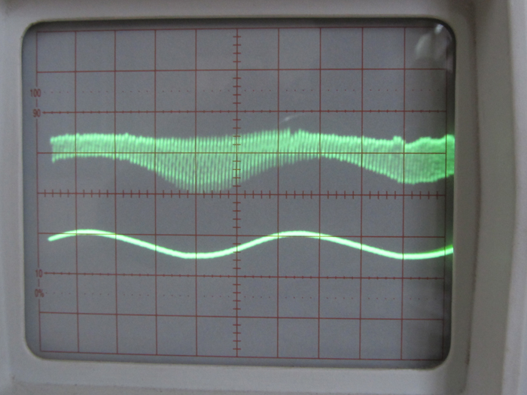

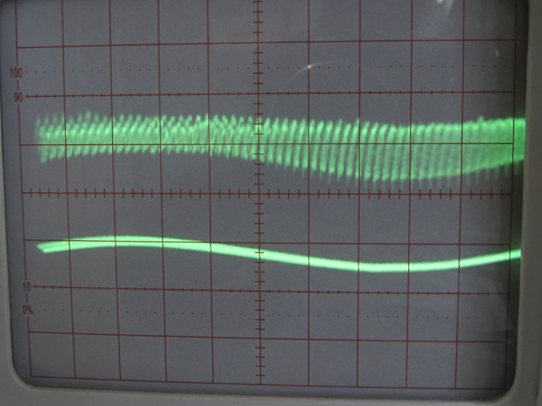

Fig. 9: Waveform Generated At Output Of Rectifier On CRO.

Step:2 Low pass filtering

A simple capacitor filter is used to filter out the low frequency amplitude variations from the rectified AM wave in the previous step. The capacitor allows only high frequency ripples to pass through it towards the ground and hence literally shorting them to the ground. The voltage appears across the capacitor will be the low frequency component of the rectified AM wave. Since this circuit filters out the low frequency component which appears like the envelope of the AM wave, this technique is called ‘envelope detection’

## Demodulation contd.

The circuit diagram and the image of the circuit wired in the breadboard are shown in the following figure:

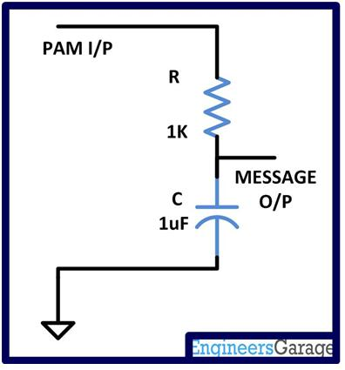

Fig. 10: Circuit Diagram Of Low Pass Filter

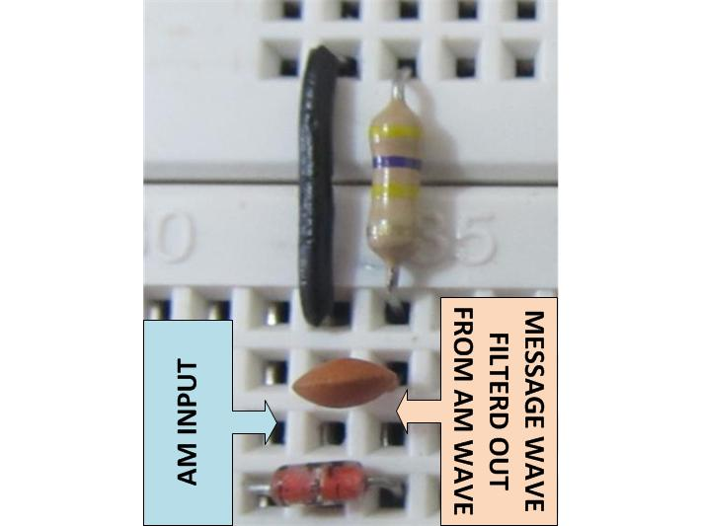

Fig. 11: Circuit Of Low Pass Filter On Breadboard

The capacitor used to short the high frequency carrier component through the ground is of the same value which has been used to generate the same frequency in the Wien bridge oscillator for the carrier frequency generation circuit. Any other capacitor will develop considerable impedance while the high frequency carrier component flows through it towards ground, and hence makes it impossible to eliminate the high frequency by shorting them to the ground.

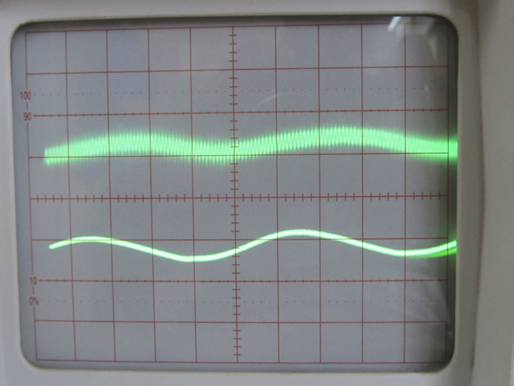

Fig. 12: Message Wave Of AM Modulation On CRO

The rectifier and the filter circuits form the actual demodulation circuitry for the AM modulated wave. So far the detection of the message wave is done but it needs to be amplified for better SNR and for an increased voltage so that it can be used with other circuits.

Step: 3 Amplification

In this project the amplification is done using a simple transistor based amplifier circuit. The NPN transistor in the circuit is wired in fixed bias common emitter configuration. The circuit used in this project along with the image of the circuit wired in the breadboard is shown below:

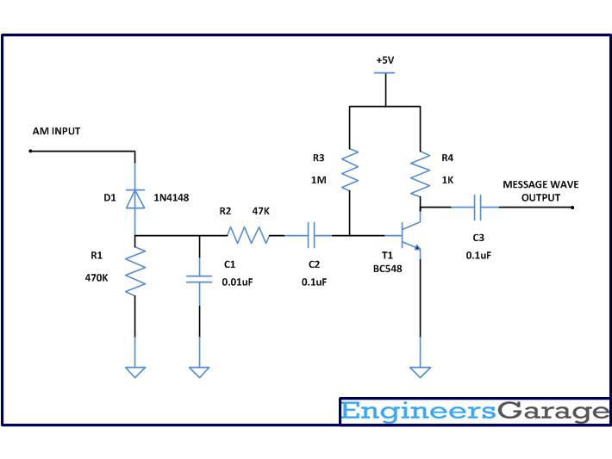

Fig. 13: Circuit Diagram Of Amplification With NPN Transistor

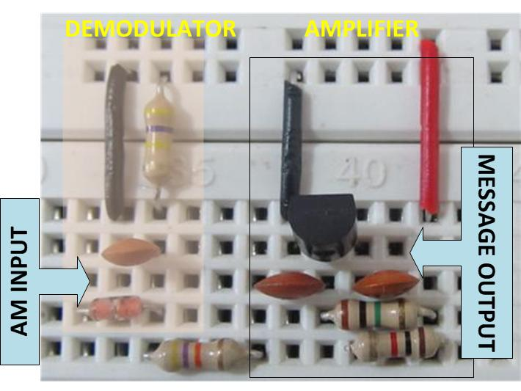

Fig. 14: Amplification Circuit With NPN Transistor On Breadboard

The Demodulator circuit is connected to an amplifier through a 47K ohm resistance so as to avoid the loading effect of the weak signal by the input of the amplifier circuit. This circuit uses a NPN transistor BC548 which has a very good current gain with a base current limiting resistor and a collector resistor. The base current limiting resistor is selected as high valued as possible since the transistor already has a higher current amplification factor (hfe). The amplified current flows through the collector resistor and develops a voltage drop which can then be coupled out using an output coupling capacitor. The input and the output coupling capacitors are used to allow only the varying component to flow in and out of the amplifier circuit. Note that the coupling capacitors are used here to couple only the message signal to the input and output of the transistor amplifier and hence their values are selected in same as those used in the message signal generating Wien bridge circuit discussed in the article AM modulation . One can use any other amplifier circuit or an external amplifier device to amplify the already detected message wave and hence this particular circuit dose not forms a part of standard AM demodulator circuit.

Note that the single stage transistor amplifier will introduce a 180 degree phase shift on the amplified   output wave as shown in the following image of demodulated wave with the original message wave on a dual channel CRO.

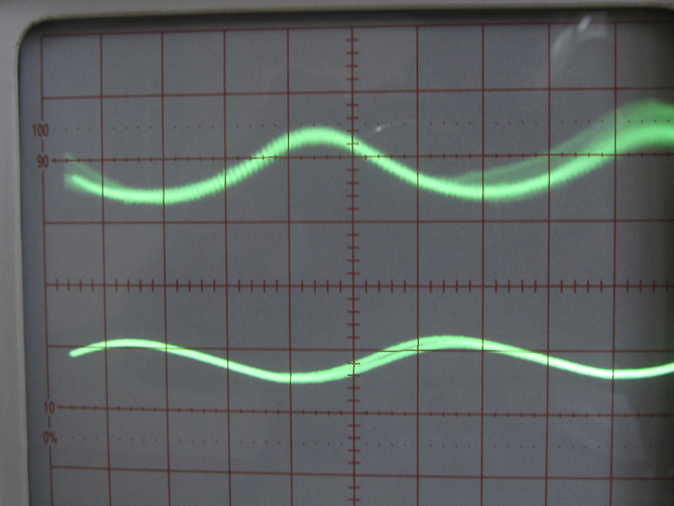

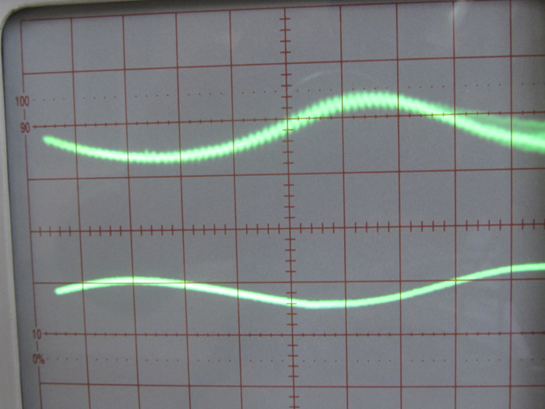

Fig. 15: Waveform Of Demodulation with original message wave On CRO

8MHz AM radio transmitter

This is an 8MHz amplitude modulated (AM) radio transmitter, which I built mainly for work, and also as an exercise in electronics (it is the first RF transmitter I`ve ever built). We wanted to have a simple radio transceiver design at our disposal for some possible projects in the future that might require.

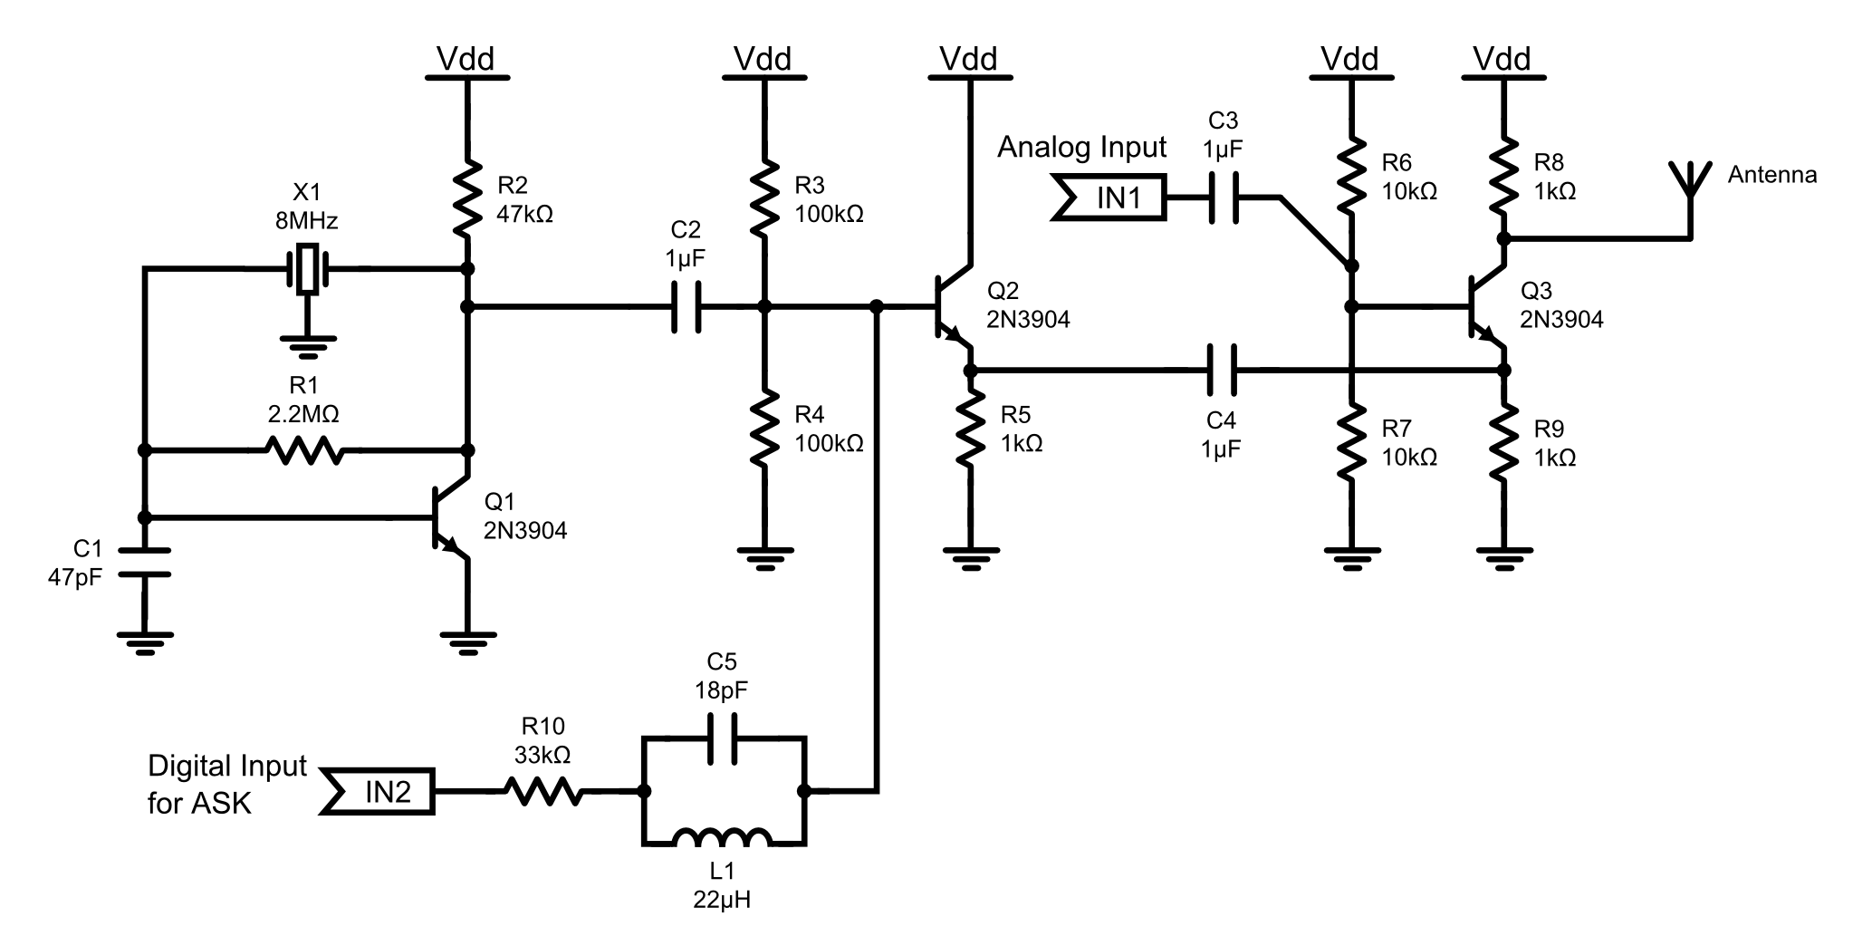

### PLL FM demodulator.

A simple PLL FM demodulator circuit using IC XR2212 is shown here. XR2212 is a highly stable, monolithic PLL (phase locked loop) IC specifically designed for communication and control system applications. The IC has 0.01 Hz to 300KHz frequency range, 4.5 to 20V operating voltage range, 2mV to 3Vrms dynamic range, high temperature range, TTL / CMOS compatibility and adjustable tracking range. The block diagram of a typical PLL FM demodulator circuit is shown below.

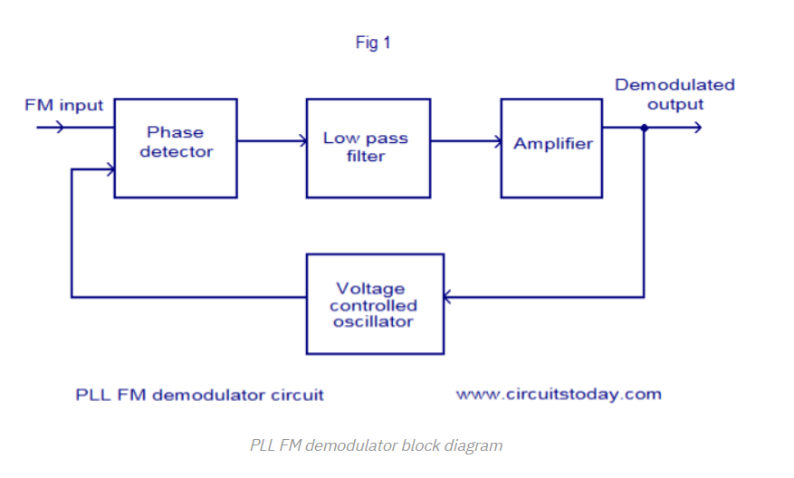

The working of a PLL FM demodulator is very easy to understand.The input FM signal and the output of the VCO is applied to the phase detector circuit. The output of the phase detector is filtered using a low pass filter, the amplifier and then used for controlling the VCO. When there is no carrier modulation and the input FM signal is in the center of the pass band (i.e. carrier wave only) the VCO’s tune line voltage will be at the center position. When deviation in carrier frequency occurs ( that means modulation occurs) the VCO frequency follows the input signal in order to keep the loop in lock. As a result the tune line voltage to the VCO varies and this variation is proportional to the modulation done to the FM carrier wave. This voltage variation is filtered and amplified in order to get the demodulated signal.

#### Circuit diagram.

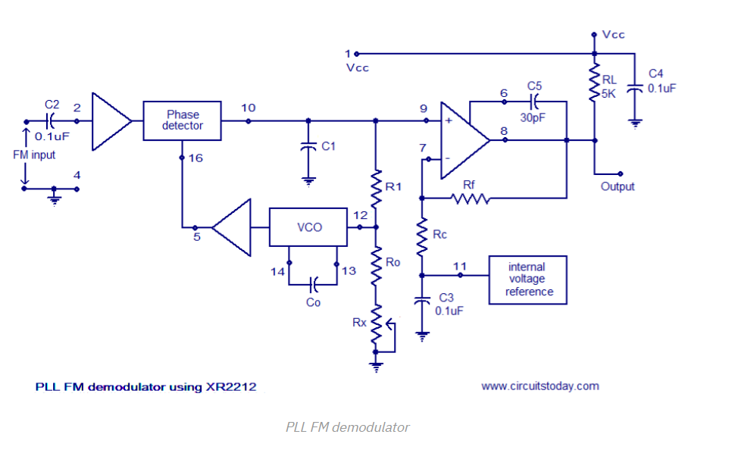

Composite FM signal is applied to pin 2 of the IC. Input impedance of this pin is around 20K and the voltage swing of the input signal must be between 10mV to 5V. Capacitor C5 is meant for frequency compensating the internal output opamp. The capacitor C5 is connected between pin 6 and 8 of the IC and its value can be 20 to 30pF. Co is the timing capacitor for the internal voltage controlled oscillator (VCO). The VCO frequency is inversely proportional to the value of the timing capacitor Co and its range can be 200pF to 10uF. C4 is the input supply by-pass capacitor. Free running frequency of the VCO is determined by the external timing resistor Ro. Value of Ro can be between 10 and 100K. Rx can used for fine tuning the VCO frequency. R1 and C1 forms a PLL loop filter. Resistors Rf and Rc sets the gain of the output amplifier section.

#### Design.

1. Center frequency of the voltage controlled oscillator (VCO) , fo must be selected equal to the frequency of the FM carrier wave.
2. Value of Ro can be in the range 10K to 100k and the recommended value is 20K.
3. Co = 1/Rofo
4. C1 = Co/4.
5. Rf can be taken as 100K and RC can be taken as 80.6K for a +/-4V output swing.
6. R1 can be taken as 89.3K.

Vhf-modulator

This circuit uses an oscillator (2N2222) and a diode Dl as a nonlinear mixer. The frequency is set by a slug in Ll. RFCl, Cl, and RFC2 form a low-pass filter to pass video and block rffrom the video source

